Supporting Information

Rapid determination of immunosuppressive drug concentrations in whole blood by Coated Blade Spray-Tandem Mass Spectrometry (CBS-MS/MS)

Germán Augusto Gómez-Ríos, Marcos Tascon, Nathaly Reyes-Garcés, Ezel Boyacı, Justen James Poole, Janusz Pawliszyn*

Department of Chemistry, University of Waterloo, Waterloo, Ontario N2L 3G1, Canada

*Corresponding author:
Tel.: +1 519 888 4641; fax: +1 519 746 0435. E-mail address: Janusz@uwaterloo.ca (J. P.).

Compound | Polarity | Precursor (m/z) | Product (m/z) | Collision Energy (V) | RF Lens (V)
Tacrolimus | Positive | 821.488 | 768.35 | 19.86 | 85
Tacrolimus-d2C1 | Positive | 824.522 | 771.481 | 20.416 | 85
Sirolimus | Positive | 931.54 | 864.425 | 16.522 | 85
Sirolimus-d3 | Positive | 934.606 | 864.497 | 16.067 | 88
Everolimus | Positive | 975.578 | 908.454 | 16.421 | 87
Everolimus-d4 | Positive | 979.609 | 912.528 | 15.511 | 88
Cyclosporine A | Positive | 1219.8 | 1202.729 | 16.32 | 96
Cyclosporine A-d4 | Positive | 1223.87 | 1206.854 | 11.4 | 97
Table S1 Mass spectrometry parameters used to monitor each ISD.

Table S2 Calibration points for levels of tacrolimus, everolimus, and sirolimus.
Calibration points | 1 | 2 | 3 | 4 | 5 | 6 | 7
ng/mL | 1 | 2.5 | 5 | 10 | 15 | 25 | 50

Table S3 Calibration points for levels of Cyclosporine A.
Calibration points | 1 | 2 | 3 | 4 | 5 | 6 | 7*
ng/mL | 10 | 25 | 50 | 100 | 150 | 250 | 500

Table S4 Liquid check quality control (QC) standards acquired from Bio-Rad.
Calibration points [ng·mL⁻¹] | Level 1 | Level 2 | Level 3 | Level 4
Cyclosporine | 55.6 | 179 | 324 | 699
Everolimus | N/A | 3.14 | 6.78 | 17.6
Sirolimus | 3.62 | 7.74 | 13.1 | N/A
Tacrolimus | 3.94 | 9.05 | 17.0 | 26.7

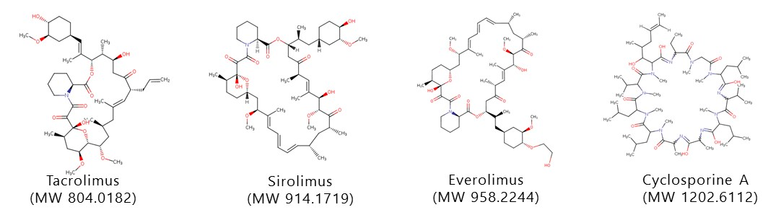
Figure S1 Chemical structure of the target analytes.

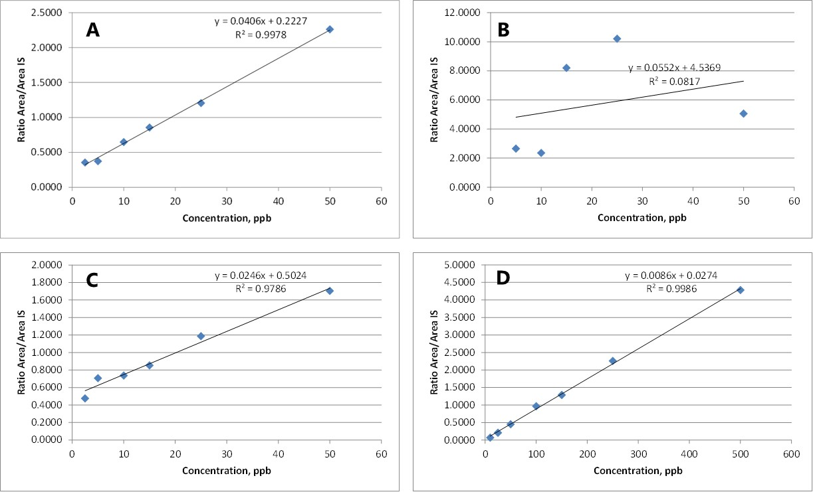
Figure S2 Quantitative determination of (A) TAC, (B) SIR, (C) EVR, and (D) CycA. Extractions were performed from 100 µL of whole human blood pre-mixed with 100 µL of a 0.1M ZnO4-solution. 20 min of extraction at 2000 rpm was followed by three rinsing steps in fresh water of 5s each.

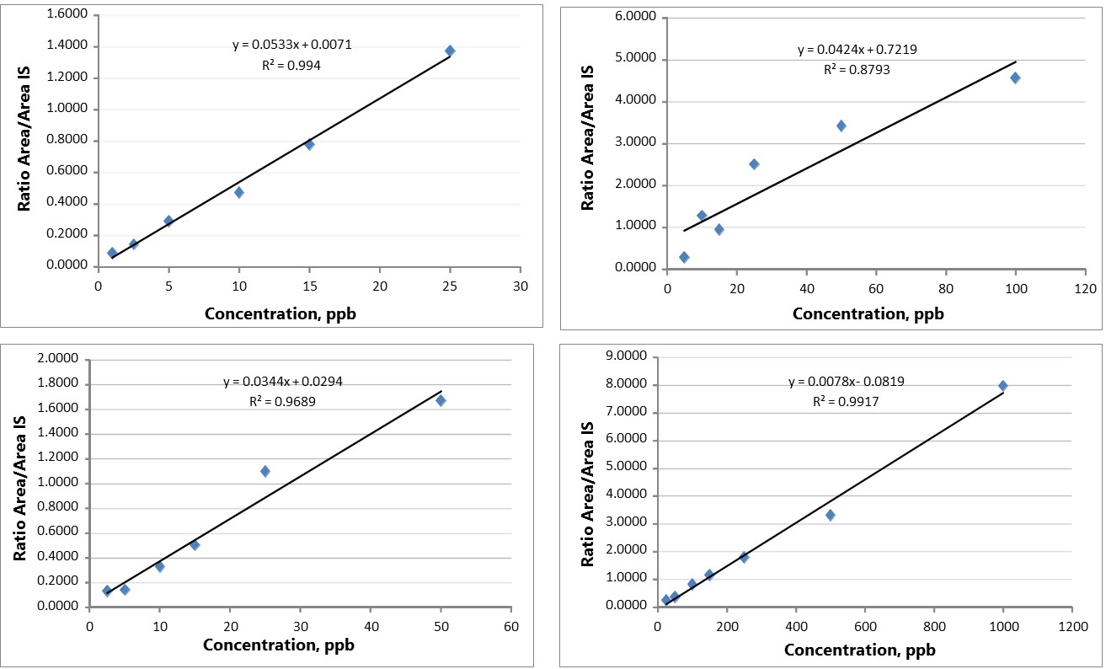
Figure S3 Quantitative determination of (A) TAC, (B) SIR, (C) EVR, and (D) CycA. Extractions were performed from 200 µL of whole human blood pre-mixed with 500 µL of a 0.1M ZnO4-solution and 500 µL of LC-MS water. 30 min extraction at 2000 rpm was followed by three rinsing steps in fresh water of 5s each.
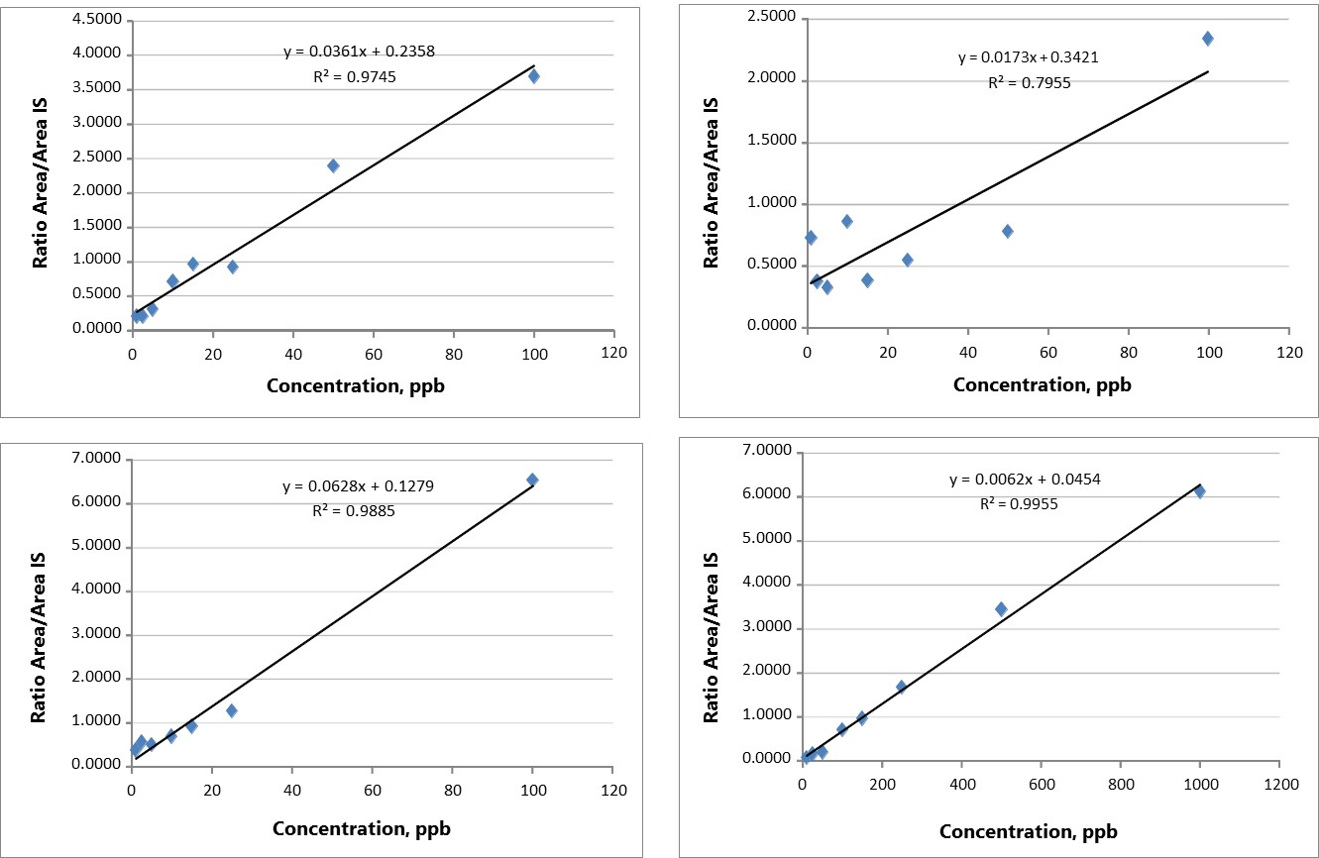
Figure S4 Quantitative determination of (A) TAC, (B) SIR, (C) EVR, and (D) CycA. Extractions were performed from 200 µL of whole human blood frozen (-80 °C, 1h) and thawed. 30 min extraction at 2000 rpm was followed by three rinsing steps in fresh water of 5s each.
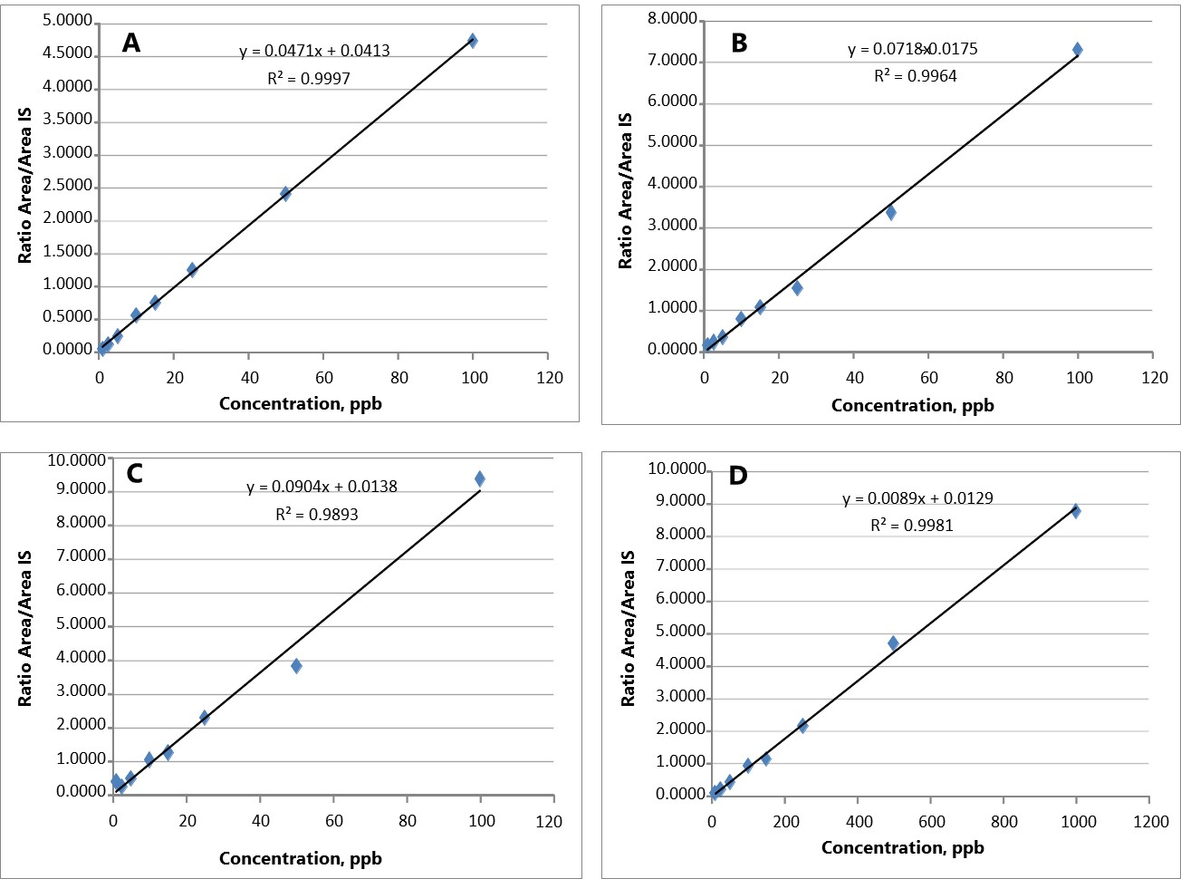

Figure S5 Quantitative determination of (A) TAC, (B) SIR, (C) EVR, and (D) CycA. Extractions were performed from 300 µL of human plasma. 30 min extraction at 2000 rpm was followed by three rinsing steps in fresh water of 5s each.
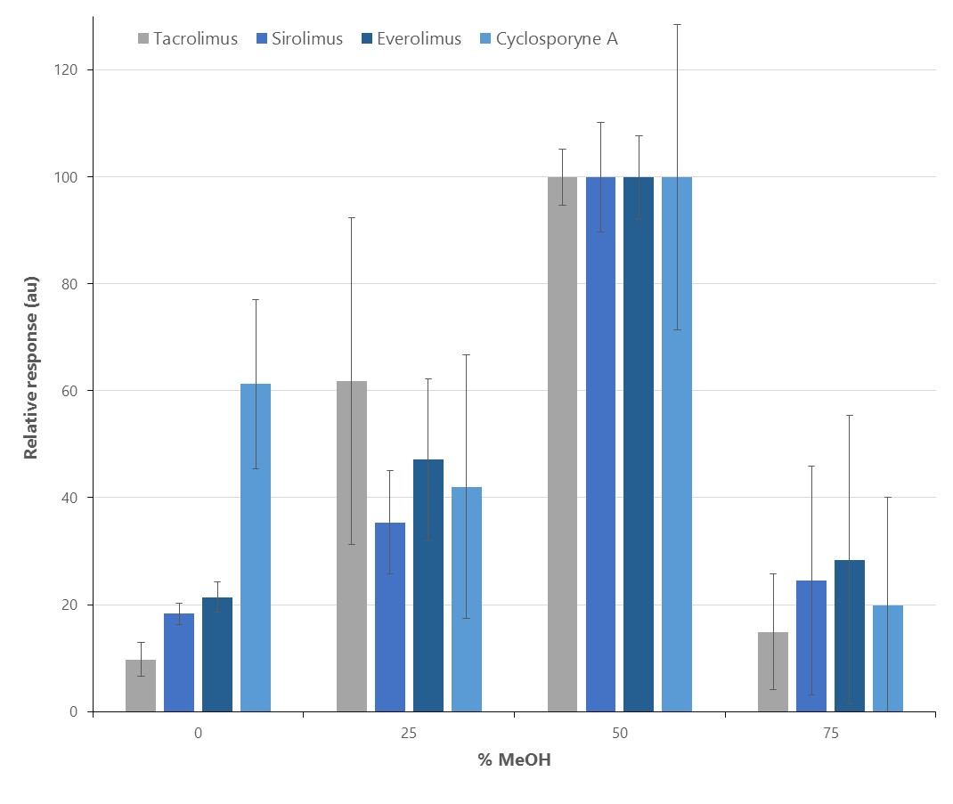

Figure S6 Optimization of organic content (MeOH, %) required to achieve the highest instrumental response. Extractions were performed from 100 µL of whole human blood spiked at 50 ng mL-1 with TAC/SIR/EVR and 500 ng mL-1 for CycA, and pre-mixed with a 0.1M ZnO4-solution and MeOH according to their respective ratios. 30 min extraction at 2000 rpm was followed by three rinsing steps in fresh water of 5s each.

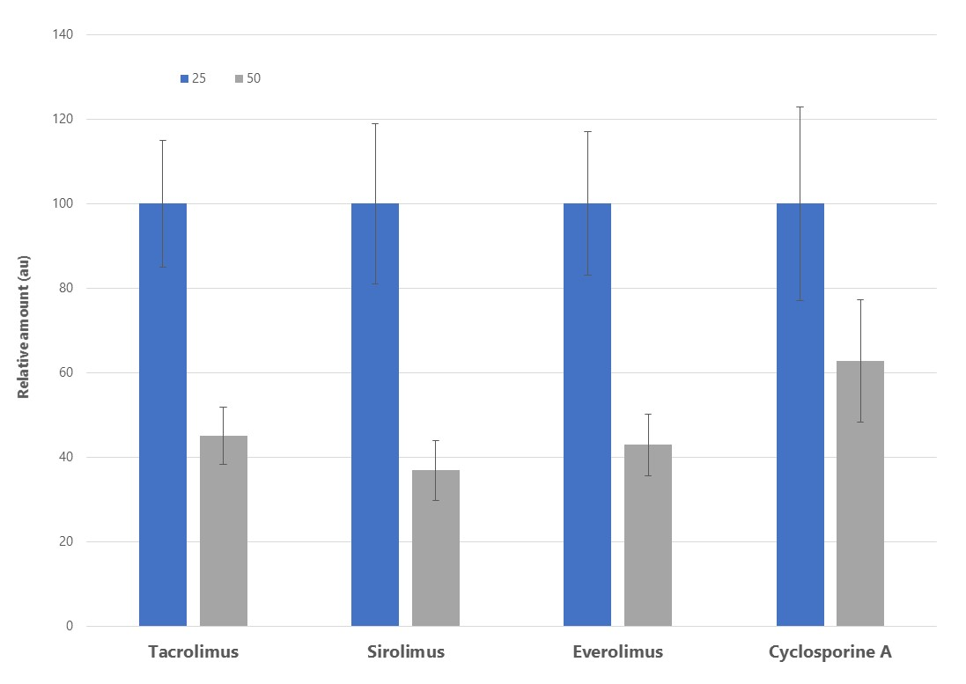
Figure S7 Optimization of organic content (ACN, %) required to achieve the highest instrumental response. Extractions were performed from 100 µL of whole human blood spiked at 50 ng mL⁻¹ with TAC/SIR/EVR and 500 ng mL⁻¹ for CycA, and pre-mixed with a 0.1M ZnO₄-solution and CAN according to their respective ratios. 30 min extraction at 2000 rpm was followed by three rinsing steps in fresh water of 5s each.

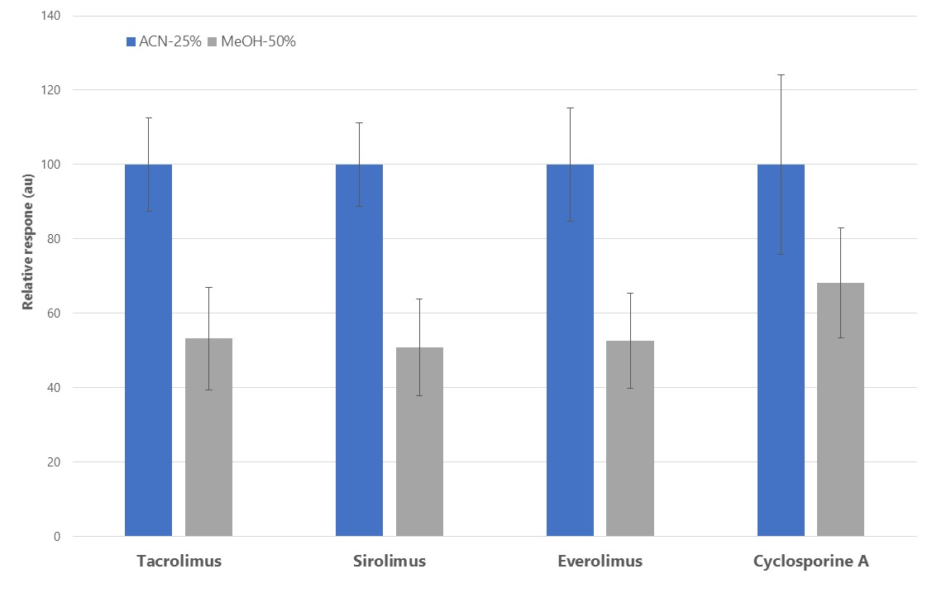
Figure S8 Comparison between two different organic solvent denaturing mixtures: 25% ACN versus 50% MeOH.

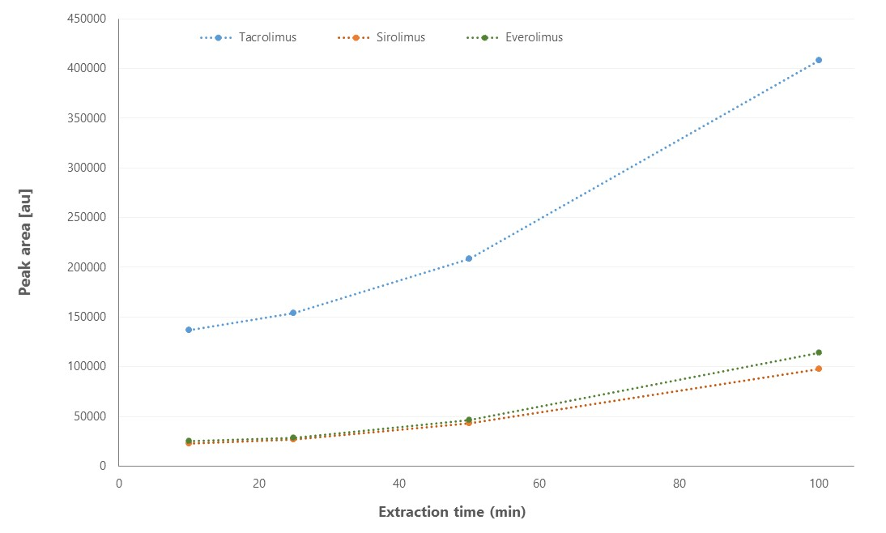
Figure S9 Extraction time profile for three of the ISDs (10, 25, 50, 100 min). Extractions were performed from whole human blood spiked at 50 ng mL⁻¹ with TAC/SIR/EVR, and pre-mixed with a 0.1M ZnO₄-solution and ACN (25%) according to their respective ratios.

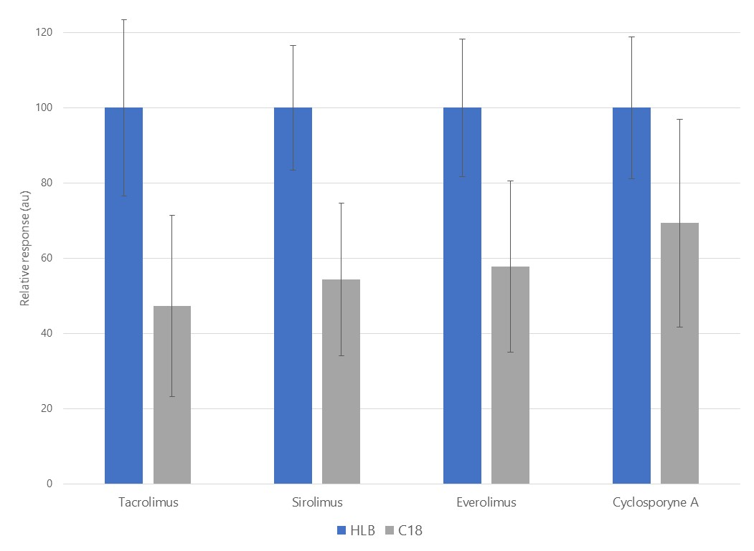
Figure S10 Comparison of two different coating chemistries for the extraction of ISDs from a modified blood-matrix. Extractions were performed from whole human blood spiked at 50 ng mL⁻¹ with TAC/SIR/EVR and 500 ng mL⁻¹ for CycA, and pre-mixed with a 0.1M ZnSO₄-solution and ACN (25%) according to their respective ratios. 90 min extraction at 2000 rpm was followed by three rinsing steps in fresh water of 5s each.

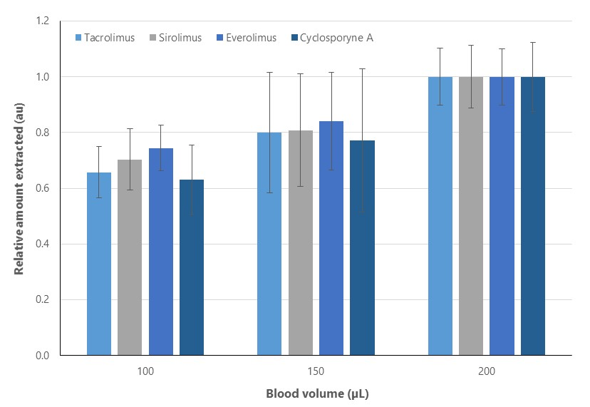

Figure S11 Comparison of three different blood sample volumes for the determination of ISDs from a modified blood-matrix. Extractions were performed from whole human blood spiked at 50 ng mL⁻¹ with TAC/SIR/EVR and 500 ng mL⁻¹ for CycA, and pre-mixed with a 0.1M ZnSO₄-solution and ACN (25%) according to their respective ratios. 90 min extraction at 2000 rpm was followed by three rinsing steps in fresh water of 5s each.

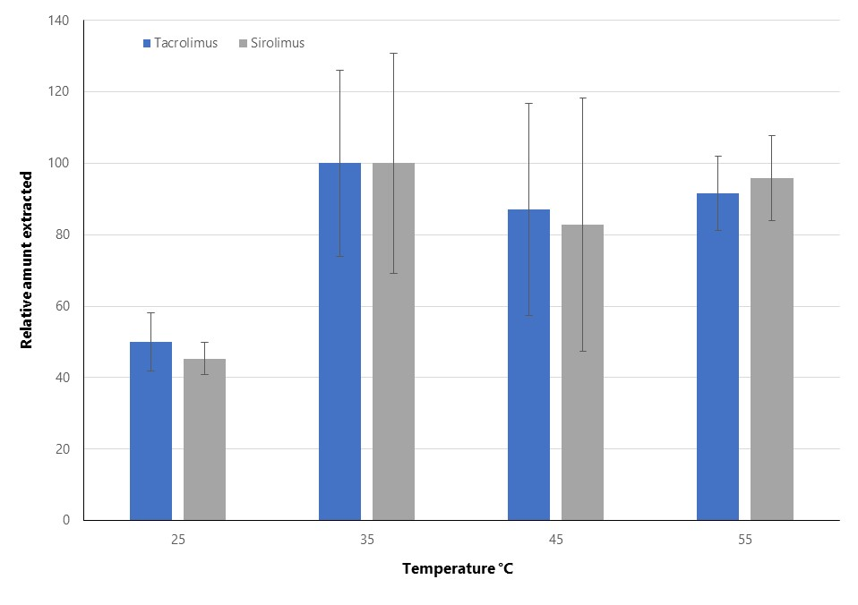Figure S12 Comparison of four different extraction temperatures for the determination of ISDs from a modified blood-matrix. Extractions were performed from whole human blood spiked at 50 ng mL⁻¹ with TAC/SIR/EVR and 500 ng mL⁻¹ for CycA, and pre-mixed with a 0.1M ZnSO₄-solution and ACN (25%) according to their respective ratios. 90 min extraction at 2000 rpm was followed by three rinsing steps in fresh water of 5s each.

