Supporting Information
Insights into the Effect of the PDMS-layer on the Kinetics and Thermodynamics of Analyte Sorption onto the Matrix-Compatible SPME Coating
Érica A. Souza-Silva†¹, Emanuela Gionfriddo¹, Md. Nazmul Alam¹, Janusz Pawliszyn¹*.
† Current Address: Universidade Federal do Rio Grande do Sul, 91501-970 Porto Alegre, Rio Grande do Sul, Brazil
¹ Department of Chemistry, University of Waterloo, Waterloo, Ontario, Canada.
Corresponding author’s name: Janusz Pawliszyn
Corresponding author’s phone number: 1-519-888-4567 ext. 84641
Corresponding author’s e-mail: janusz@sciborg.uwaterloo.ca

Content:
Table S1 - Model analytes in standard mixture for coating evaluation………………………………………S-3
Figure S1 - Structures of model analytes employed in the current coating evaluation………………S-4
Figure S2 - Representative chromatograms of analytes from standard mixture extracted from water using commercial PDMS/DVB fiber (A), and PDMS-overcoated (B)………………………………….S-5
Table S2 - Calculated values of diffusion in water (Dw) at 30 ºC………………………………………………..S-6
Table S3 - Calculated values of aqueous boundary layer thicknesses (in µm) for different sample agitation speed (in rpm)……………………………………………………………………………………………………………S-7
Figure S3 - Mass uptake profiles of most polar target analytes obtained from aqueous solutions at 30 ºC………………………………………………………………………………………………………………………………………S-8/9
Figure S4 - Schematic representation of the model domains used in the Comsol modeling and simulations……………………………………………………………………………………………………………………………..S-10
Table S4 - Parameters used in the modeling and simulations…………………………………………….…..S-11
Figure S5 – Concentration profile from the coating inner surface to the bulk of the solution. Infinite volume of sample was considered for the simulation. a) Concentration profile for a polar analyte, 1, 3-dinitrobenzene; b) concentration profile for a non-polar analyte, pendimethalin. Parameters used in the simulation is shown in Table S4 …………………………………………………………………………….S-12

Table S1 - Model analytes in standard mixture for coating evaluation.
 | Working Mixture  ( µg/mL) | Log P  (pH 7) | MW (g/mole) | Quant. Ion (m/z)
Nitrobenzene | 50 | 1.90 | 123 | 77
1,3-Dinitrobenzene | 150 | 1.43 | 168 | 168
2,6-Dinitrotoluene | 75 | 2.42 | 182 | 165
Trifluralin | 5 | 5.07 | 325 | 306
4-Phenylphenol | 20 | 3.20 | 170 | 170
Diazinon | 7.5 | 3.40 | 304 | 304
Chlorothalonil | 15 | 2.94 | 266 | 266
Parathion | 5 | 3.83 | 291 | 291
Pendimethalin | 5 | 5.18 | 281 | 252
p,p'-DDE | 2.5 | 6.00 | 318 | 318
Diazepam | 100 | 2.80 | 284 | 256

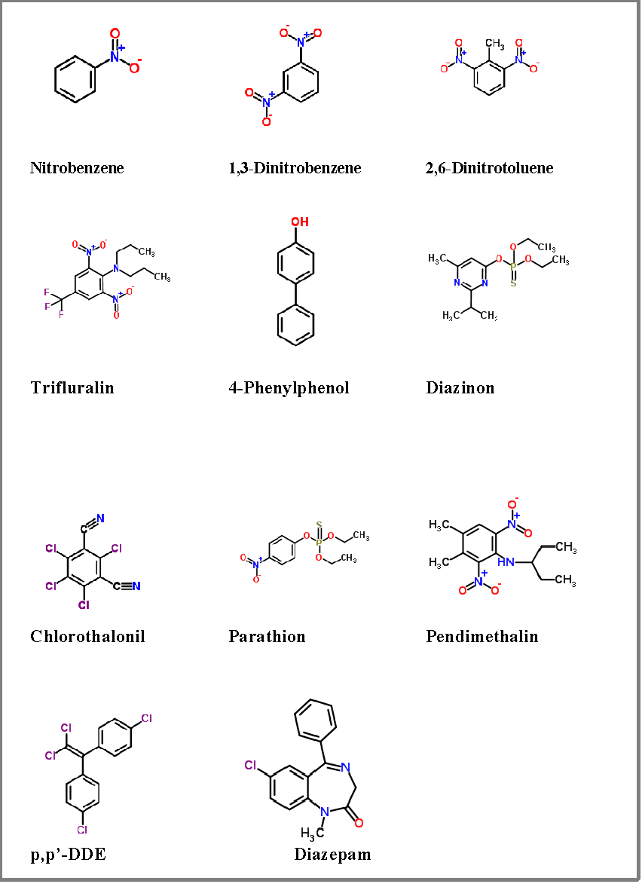
Figure S1 - Structures of model analytes employed in the current coating evaluation.

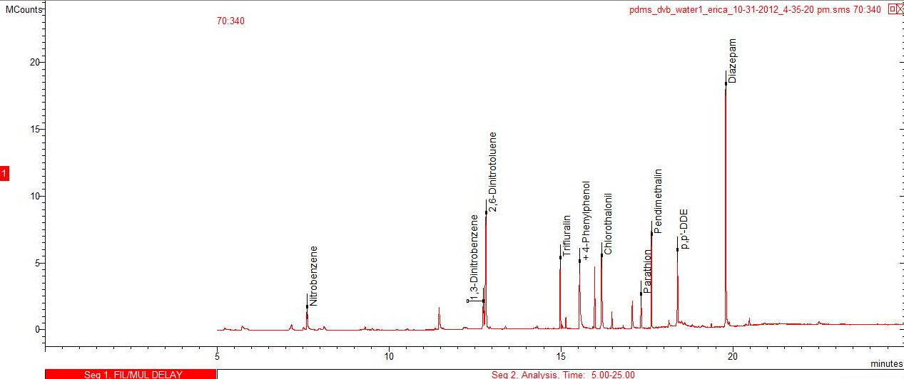
A
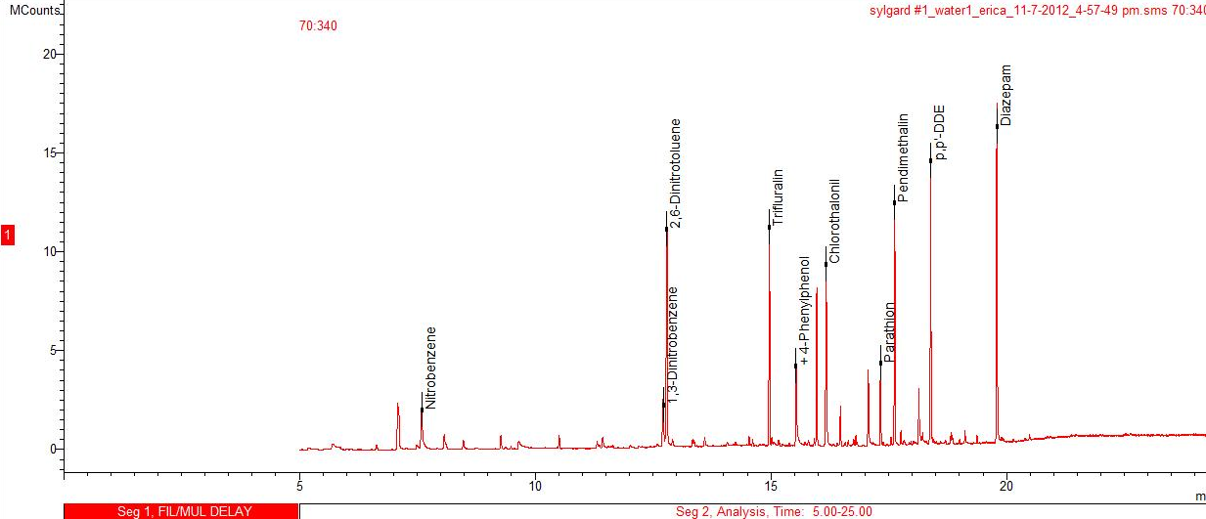
B

Figure S2 - Representative chromatogram: analytes from standard mixture extracted from water using commercial PDMS/DVB fiber (A), and PDMS-overcoated (B).

Table S2 Calculated values of diffusion in water (D_{w}) at 30 ºC.
D_{w}
Nitrobenzene | 1.01E-05
1,3-Dinitrobenzene | 8.99E-06
2,6-Dinitrotoluene | 8.29E-06
Trifluralin | 5.51E-06
4-Phenylphenol | 7.76E-06
Diazinon | 5.75E-06
Chlorothalonil | 6.92E-06
Parathion | 6.38E-06
Pendimethalin | 5.77E-06
4,4'-DDE | 5.90E-06
Diazepam | 5.87E-06

Table S3 Calculated values of aqueous boundary layer thicknesses (in µm) for different sample agitation speed (in rpm)
 | PDMS/DVB |  | 1 Layer PDMS overcoat |  | 2 Layers PDMS overcoat
 | δ₅₀₀ rpm | δ₁₅₀₀ rpm | δ₅₀₀ rpm | δ₁₅₀₀ rpm | δ₅₀₀ rpm | δ₁₅₀₀ rpm
Nitrobenzene | 10.98 | 5.55 | 11.28 | 5.71 | 11.85 | 5.99
1,3-Dinitrobenzene | 10.5 | 5.31 | 10.79 | 5.46 | 11.33 | 5.74
2,6-Dinitrotoluene | 10.18 | 5.15 | 10.46 | 5.29 | 10.99 | 5.56
Trifluralin | 8.72 | 4.41 | 8.96 | 4.53 | 9.41 | 4.76
4-Phenylphenol | 9.93 | 5.03 | 10.2 | 5.16 | 10.72 | 5.42
Diazinon | 8.86 | 4.48 | 9.11 | 4.61 | 9.56 | 4.84
Chlorothalonil | 9.51 | 4.81 | 9.77 | 4.94 | 10.26 | 5.19
Parathion | 9.22 | 4.66 | 9.47 | 4.79 | 9.95 | 5.03
Pendimethalin | 8.87 | 4.49 | 9.12 | 4.61 | 9.58 | 4.85
4,4'-DDE | 8.95 | 4.53 | 9.19 | 4.65 | 9.66 | 4.89
Diazepam | 8.93 | 4.52 | 9.18 | 4.64 | 9.64 | 4.88

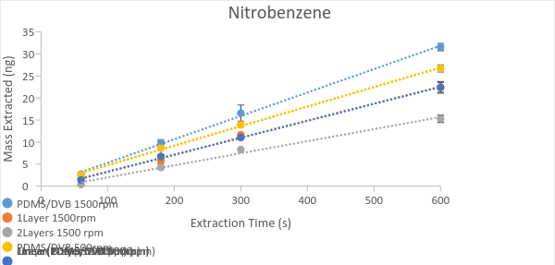
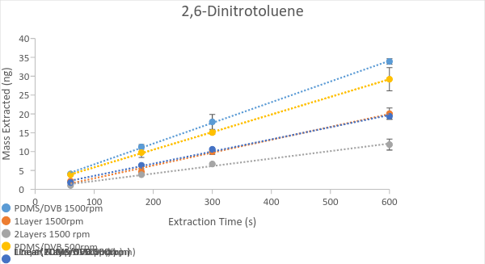
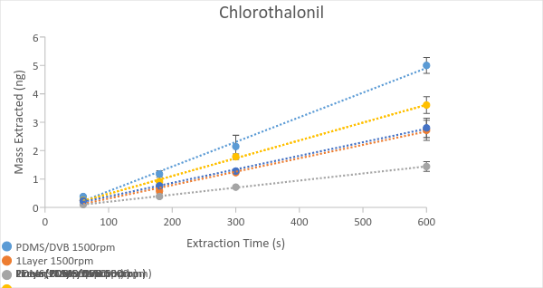

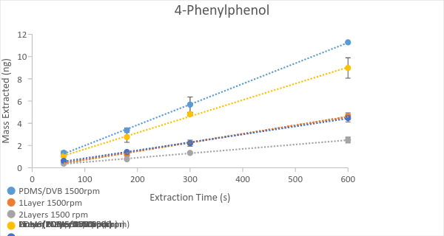
Figure S3 - Mass uptake profiles of most polar target analytes obtained from aqueous solutions at 30 ºC.

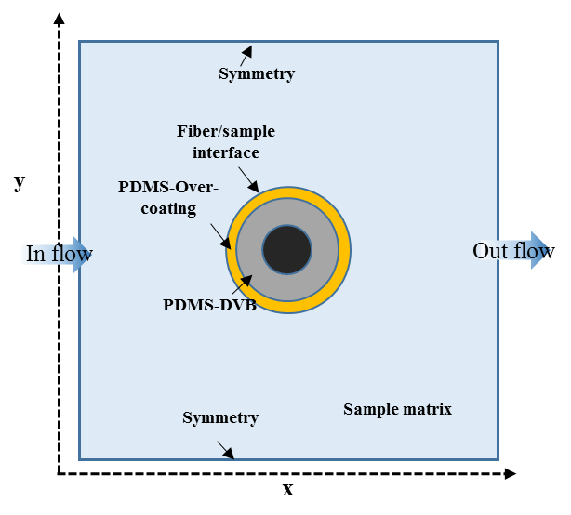
Figure S4 - Schematic representation of the model domains used in the Comsol modeling and simulations.

Table S4 Parameters used in the modeling and simulations.
Parameters | Unit | 1,3-Dinitrobenzene | Diazinon | Pendamethalin
Partition coefficient PDMS-DVB/Water |  | 886 | 18916 | 114295
Partition coefficient PDMS/Water |  | 25 | 2500 | 151356
Partition coefficient PDMS/PDMS-DVB |  | 33 | 7.51 | 5
Diffusion coefficient in water | cm²/s | 8.99E-06 | 5.75E-06 | 7.37E-06
Diffusion coefficient in coating and overcoating | cm²/s | 1.50E-06 | 9.58E-07 | 1.23E-06
Fluid linear velocity (for 1500 rpm) | cm/s | 3.5 | 3.5 | 3.5
Fluid linear velocity (for 500 rpm) | cm/s | 2.5 | 2.5 | 2.5
Temperature | C | 35 | 35 | 35
Volume of PDMS-DVB | mL | 4.40E-04 | 4.40E-04 | 4.40E-04
Volume of over coating | µl | 8.80E-02 | 8.80E-02 | 8.80E-02
Diameter of the fiber core | mm | 1.30E-01 | 1.30E-01 | 1.30E-01
Total diameter of the over coated fiber (1 Layer) | mm | 2.70E-01 | 2.70E-01 | 2.70E-01
Total diameter of the over coated fiber (2 Layers) | mm | 2.90E-01 | 2.90E-01 | 2.90E-01
Initial concentration | ng/mL | 150 | 7.5 | 5

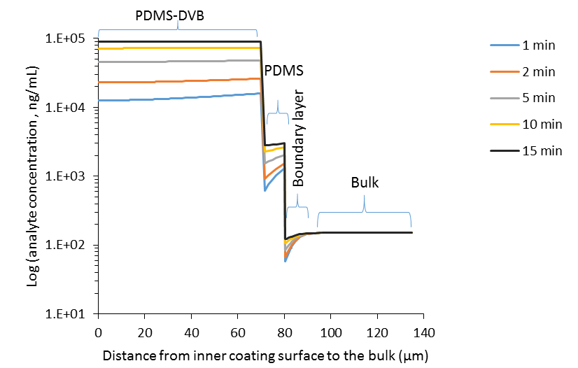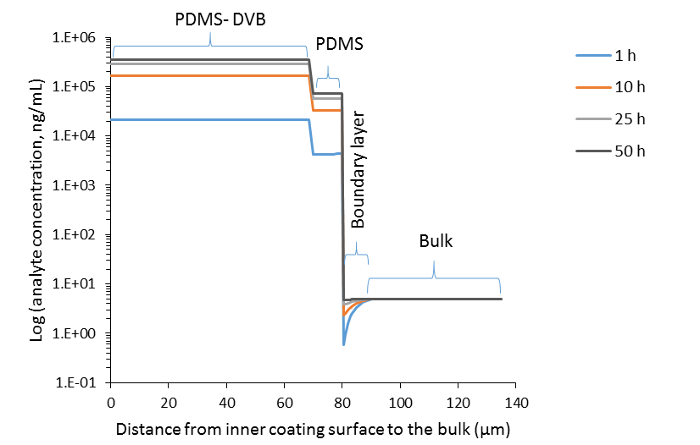
(a)
(b)
Figure S 5. Concentration profile from the coating inner surface to the bulk of the solution. Infinite volume of sample was considered for the simulation. a) Concentration profile for a polar analyte, 1, 3-dinitrobenzene; b) concentration profile for a non-polar analyte, pendimethalin. Parameters used in the simulation is shown in Table S4.
B)

