Methodical evaluation and improvement of matrix compatible PDMS-overcoated coating for direct immersion solid phase microextraction gas chromatography (DI-SPME-GC)-based applications

Érica A. Souza-Silva^{aψ}, Emanuela Gionfriddoª, Robert Shirey ^{b}, Len Sidisky^{b}, Janusz Pawliszynª*.

ª Department of Chemistry, University of Waterloo, 200 University Avenue West, Waterloo, Ontario, Canada N2L 3G1
^{b} Supelco Inc., 595 North Harrison Road, Bellefonte, PA 16823, USA
ψ Current address: Instituto de Química, Universidade Federal do Rio Grande do Sul (UFRGS), Av. Bento Gonçalves, 9500, 91501-970 Porto Alegre-RS, Brazil.
*Corresponding author’s name: Janusz Pawliszyn
Corresponding author’s phone number: 1-519-888-4567 ext. 84641
Corresponding author’s fax number: 1-519-746-0435
Corresponding author’s e-mail: janusz@sciborg.uwaterloo.ca

Supporting Information
Table S1 - Model analytes in standard mixture for coating evaluation.
 | Working Mixture  ( µg/mL) | Log P  (pH 7) | MW (g/mole) | Quant. Ion (m/z)
Nitrobenzene | 50 | 1.90 | 123 | 77
1,3-Dinitrobenzene | 150 | 1.43 | 168 | 168
2,6-Dinitrotoluene | 75 | 2.42 | 182 | 165
Trifluralin | 5 | 5.07 | 325 | 306
4-Phenylphenol | 20 | 3.20 | 170 | 170
Diazinon | 7.5 | 3.40 | 304 | 304
Chlorothalonil | 15 | 2.94 | 266 | 266
Parathion | 5 | 3.83 | 291 | 291
Pendimethalin | 5 | 5.18 | 281 | 252
p,p'-DDE | 2.5 | 6.00 | 318 | 318
Diazepam | 100 | 2.80 | 284 | 256

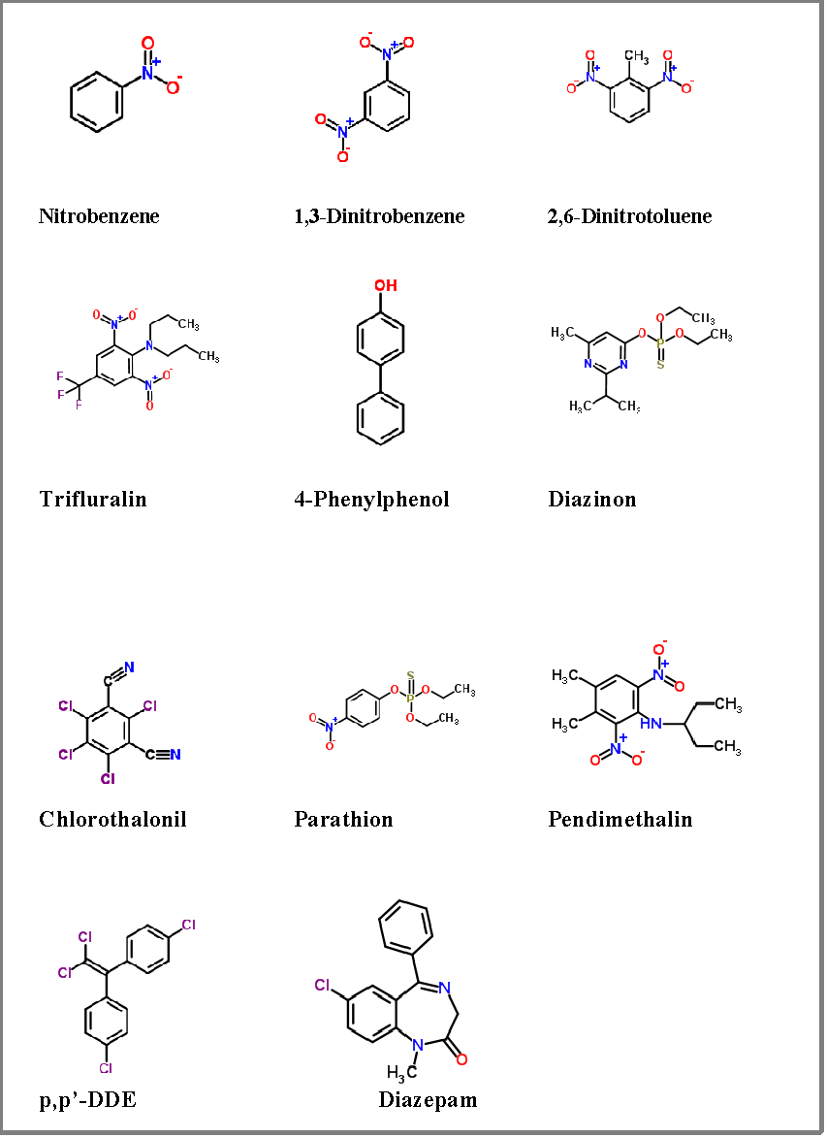
Figure S1 - Structures of model analytes employed in the current coating evaluation.

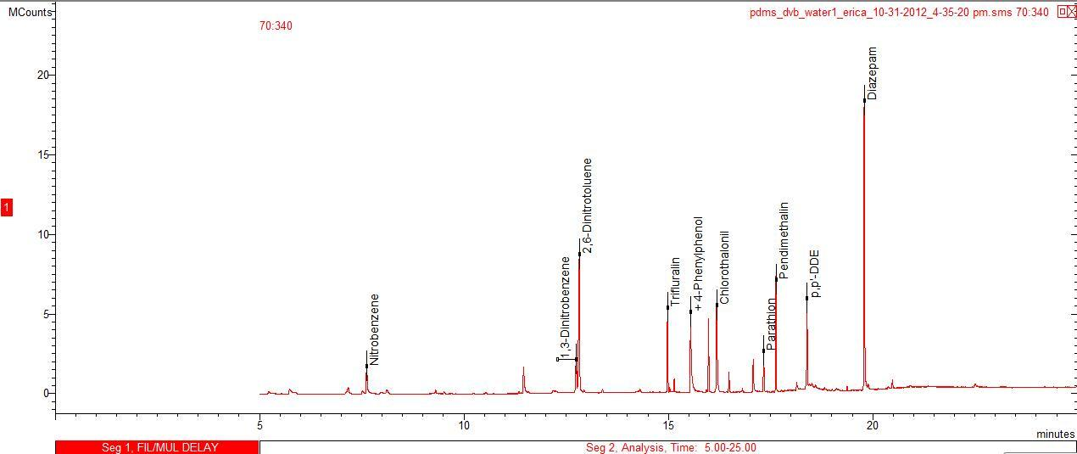
Figure S2 - Representative chromatogram: analytes from standard mixture extracted from water using commercial PDMS/DVB fiber.

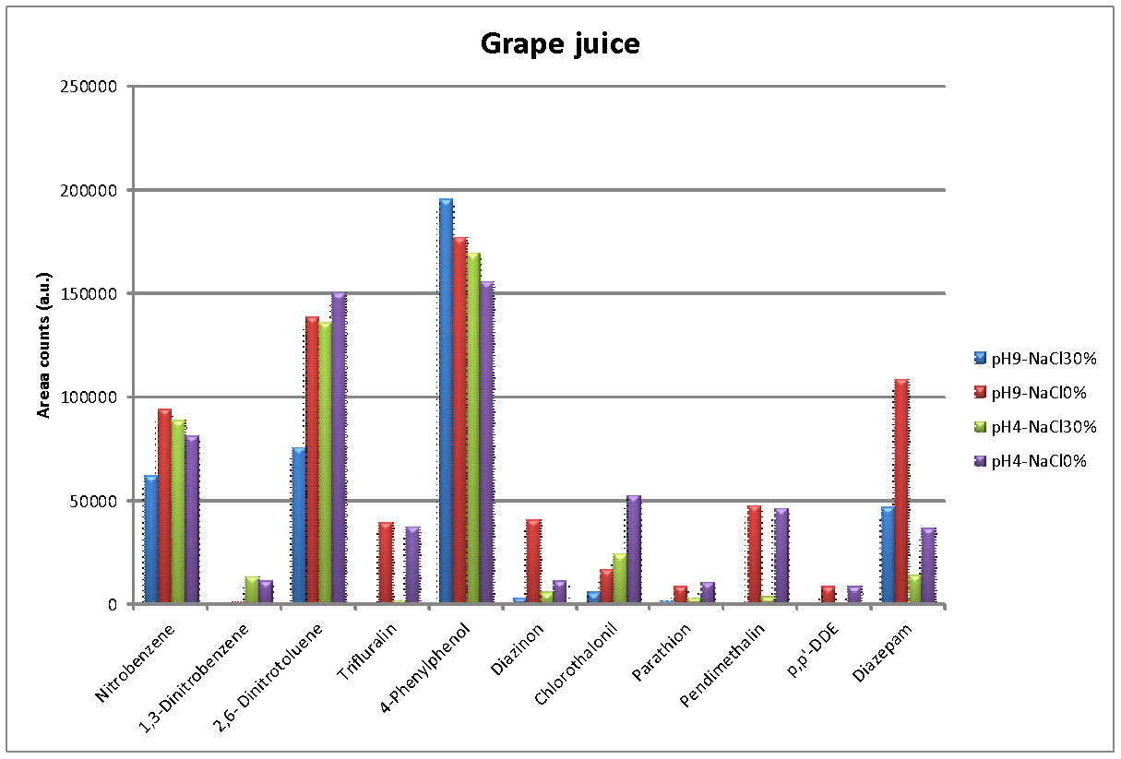
Figure S3 - pH and salt (%) dependence of the amount extracted by a PDMS/DVB fiber from grape juice samples.

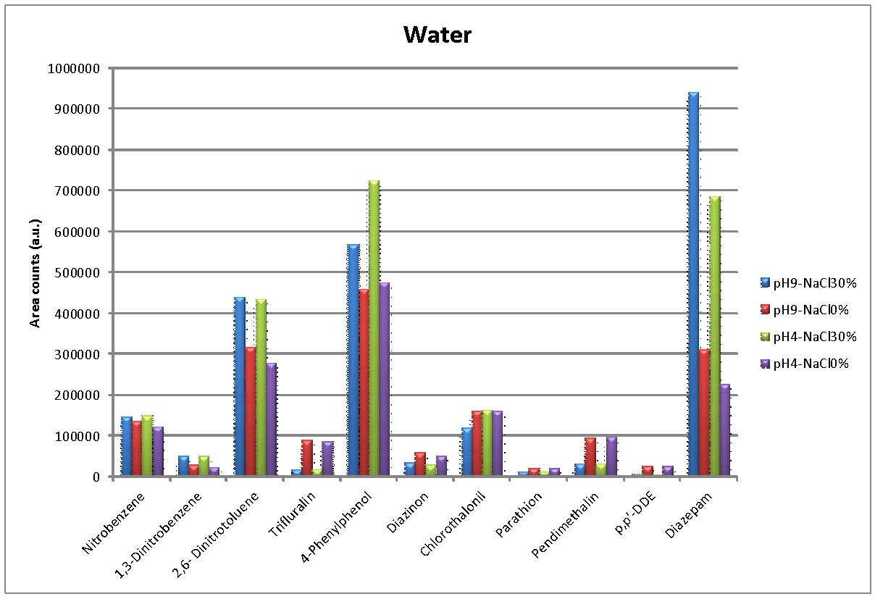
Figure S4 - pH and salt (%) dependence of the amount extracted by a PDMS/DVB fiber from water samples.

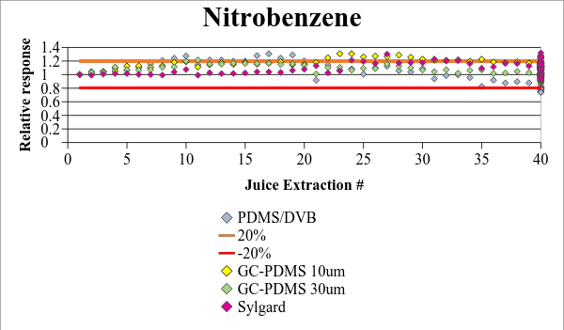
Figure S5 - Nitrobenzene: reusability profile of coatings subjected to 40 DI-SPME in Concord grape juice.

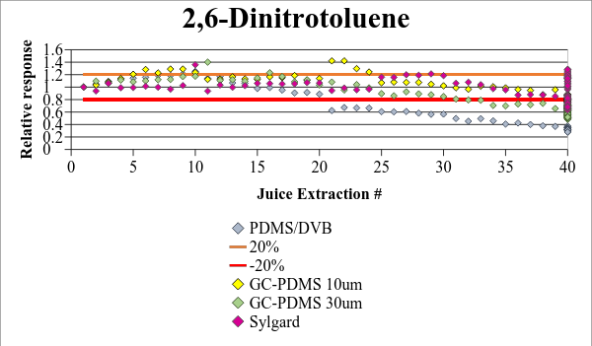
Figure S6 - 2,6-Dinitrotoluene: reusability profile of coatings subjected to 40 DI-SPME in Concord grape juice.

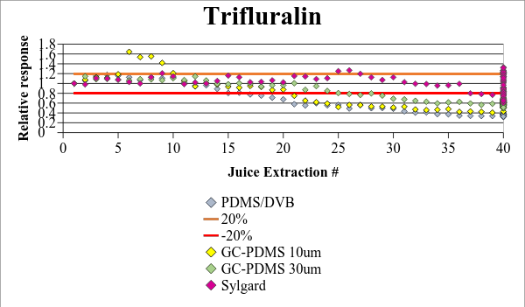
Figure S7 - Trifluralin: reusability profile of coatings subjected to 40 DI-SPME in Concord grape juice.

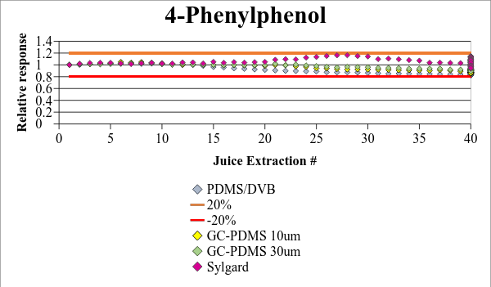
Figure S8 - 4-Phenylphenol: reusability profile of coatings subjected to 40 DI-SPME in Concord grape juice.

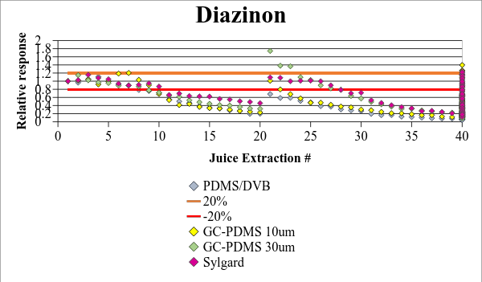
Figure S9 - Diazinon: reusability profile of coatings subjected to 40 DI-SPME in Concord grape juice.

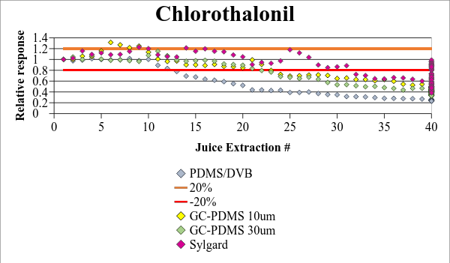
Figure S10 - Chlorothalonil: reusability profile of coatings subjected to 40 DI-SPME in Concord grape juice.

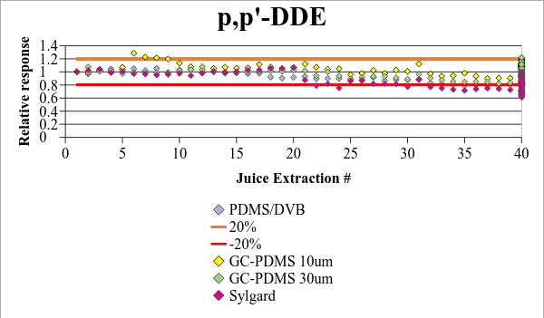
Figure S11 - p,p'-DDE: reusability profile of coatings subjected to 40 DI-SPME in Concord grape juice.

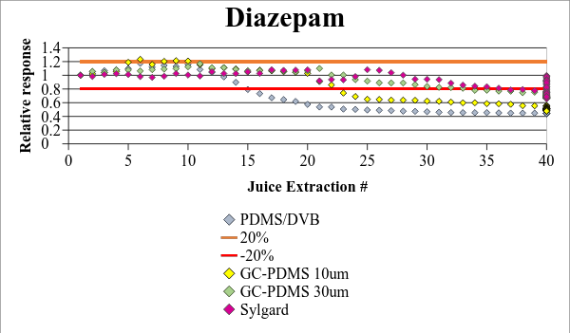
Figure S12 - Diazepam: reusability profile of coatings subjected to 40 DI-SPME in Concord grape juice.

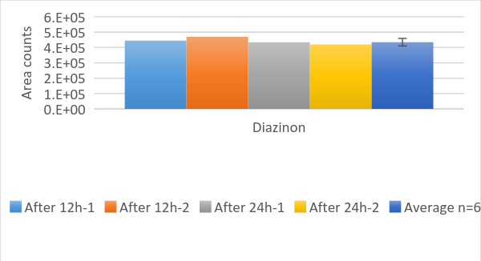
Figure S13 - Diazinon stability test in water matrix.

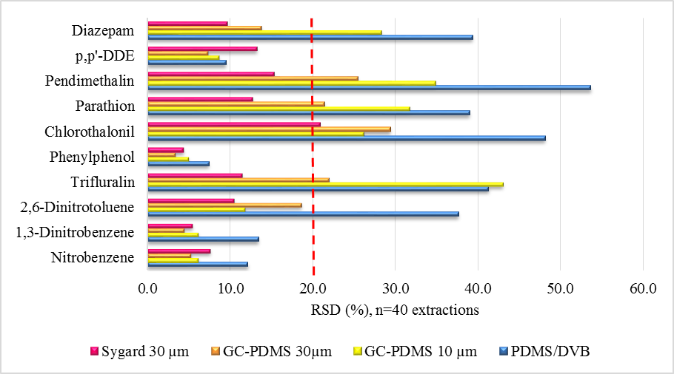
Figure S14 - Comparison of RSDs throughout 40 extractions in grape juice sample.

Table S2 - Intra-fiber: paired two samples for means (for each fiber, comparing the first 20 and last 20 extractions).
Paired t-test for means
 | PDMS/DVB | GC-PDMS 30µm | GC-PDMS  10 µm | Sylgard 30 µm
Nitrobenzene | No | No | Yes | Yes
1,3-Dinitrobenzene | No | No | No | Yes
2,6-Dinitrotoluene | No | No | No | Yes
Trifluralin | No | No | No | Yes
4-Phenylphenol | No | No | No | Yes
Chlorothalonil | No | No | No | No
Parathion | No | No | No | No
Pendimethalin | No | No | No | No
p,p’-DDE | No | Yes | Yes | No
Diazepam | No | No | No | No

Table S3 - Inter-fiber: two-sample assuming unequal or equal variances (n=100, except PDMS/DVB n=60)).
Two sample t-test
 | Syl/  GC30µm | Syl/  GC10µm | Syl/  PDMS/DVB | GC30µm/  PDMS/DVB | GC10µm/  PDMS/DVB | GC30µm/  GC10µm
Nitrobenzene | No | No | No | No | No | Yes
1,3-Dinitrobenzene | No | No | No | No | No | No
2,6-Dinitrotoluene | No | No | No | Yes | Yes | Yes
Trifluralin | No | No | No | No | No | Yes
4-Phenylphenol | No | No | No | Yes | Yes | Yes
Chlorothalonil | No | No | No | No | No | Yes
Parathion | No | No | No | No | No | No
Pendimethalin | No | No | No | No | No | Yes
p,p’-DDE | No | No | No | No | No | No
Diazepam | Yes | No | No | No | Yes | No

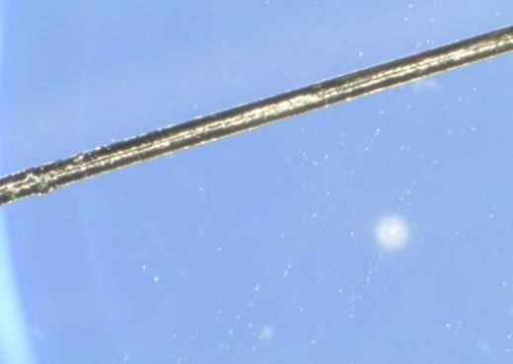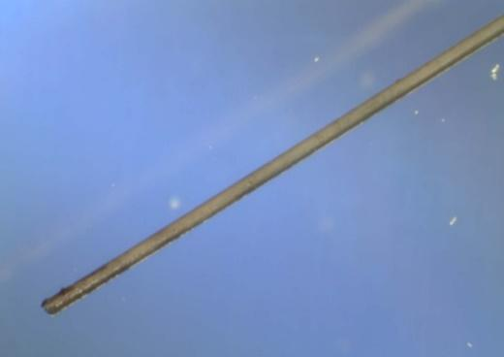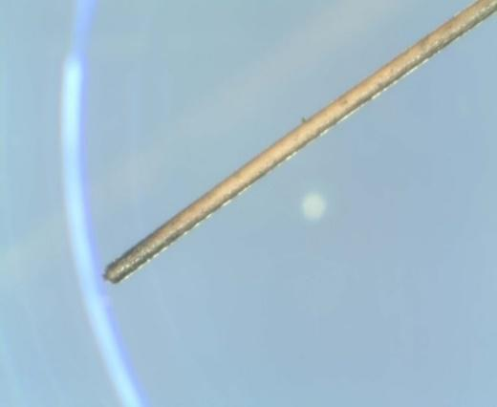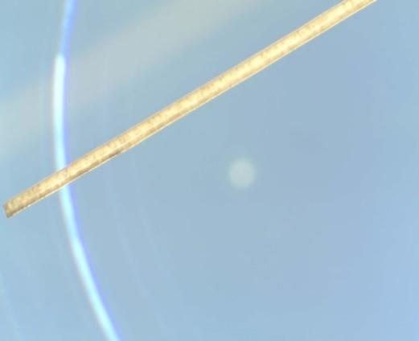
PDMS/DVB
GC- PDMS 10 µm
Sylgard 30 µm
Figure S15 - Microscopic pictures of coatings after 60 extractions in grape juice.
GC-PDMS 30 µm

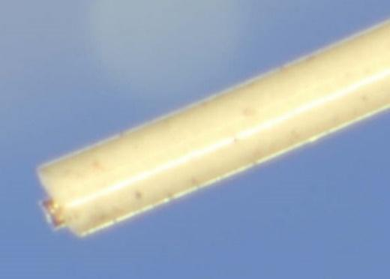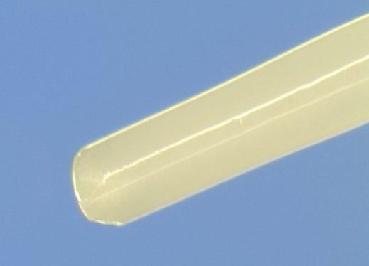
Sylgard 30 µm
GC- PDMS 30 µm
Figure S16 - Overcoated fiber tips.

Sylgard θ 109.73º

GC-PDMS θ 77.99º

Figure S17 – Water contact angle images for both types of PDMS obtained by measuring the contact angle of 30 µL water drops according to the sessile drop method. Images were acquired every 2 s over a 10 min period, and repeated three times. Contact angle measurements were collected using Axisymmetric Drop Shape Analysis (ADSA).

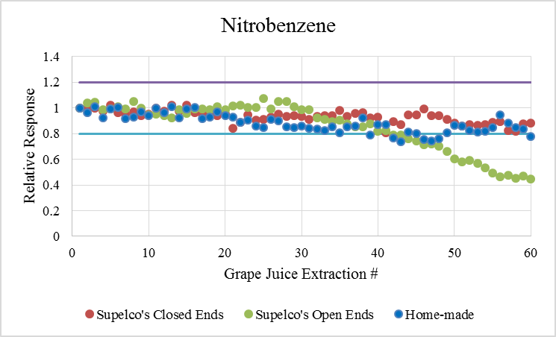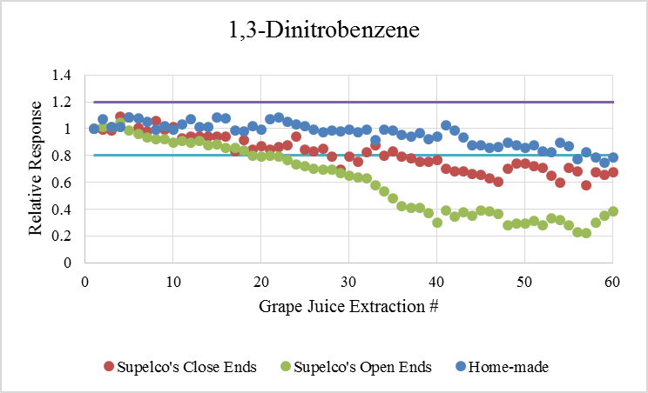
A
B
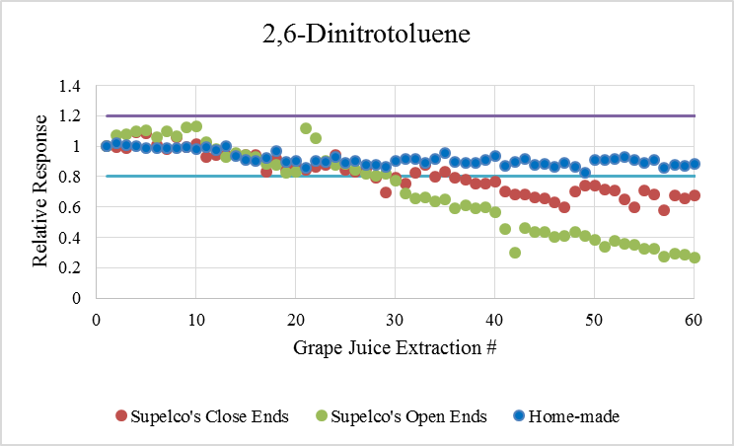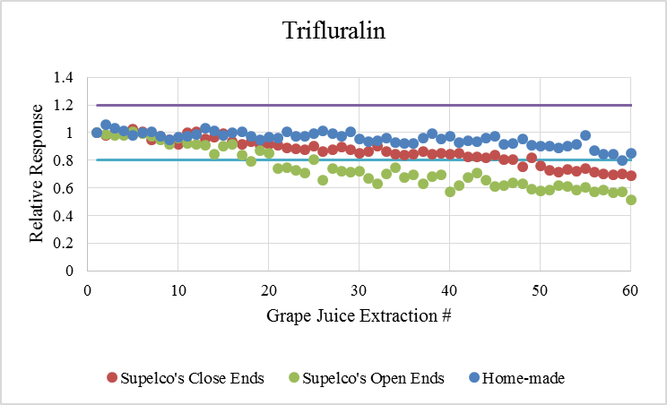
C
D
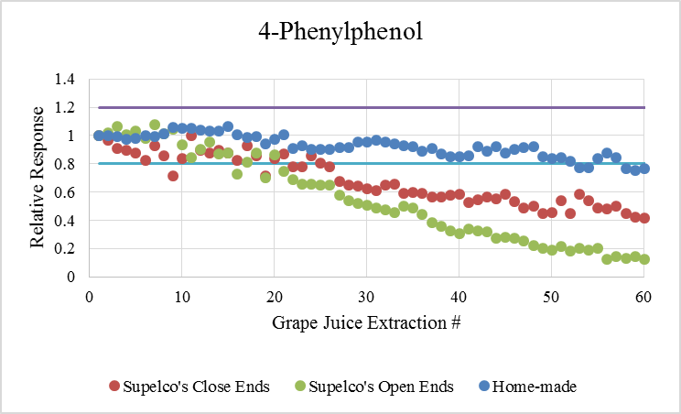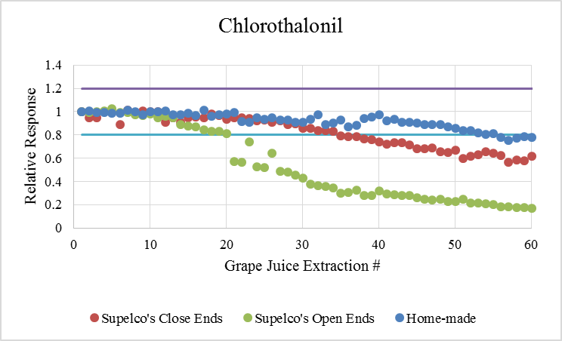
E
F
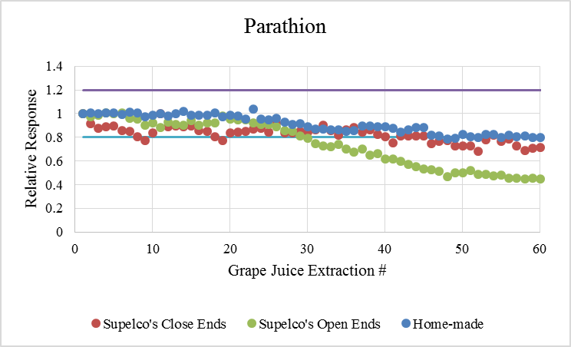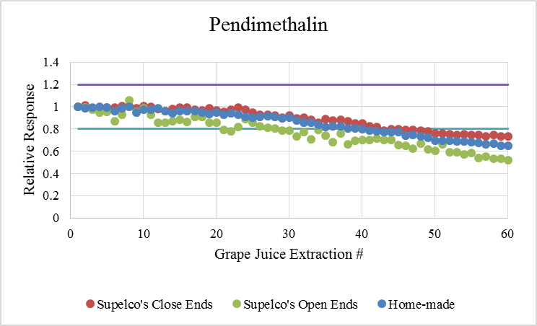
G
H
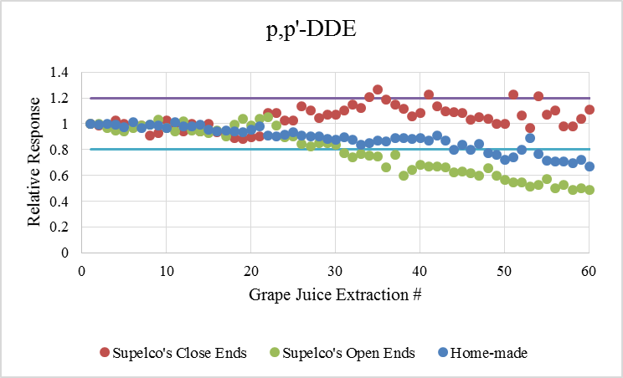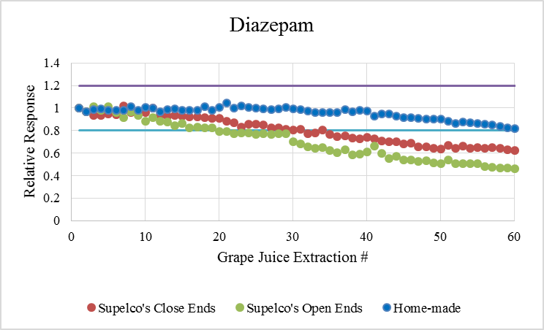
I
J
Figure S18 - Reusability profile of coatings subjected to 60 DI-SPME in Concord grape juice.

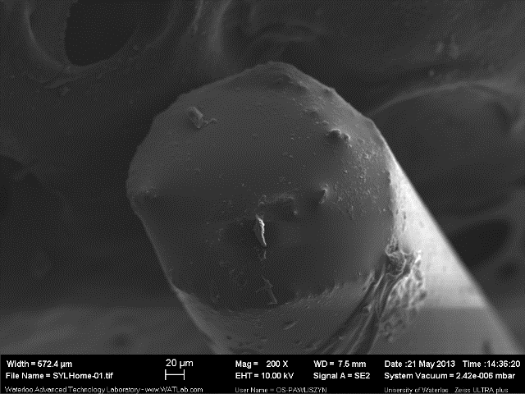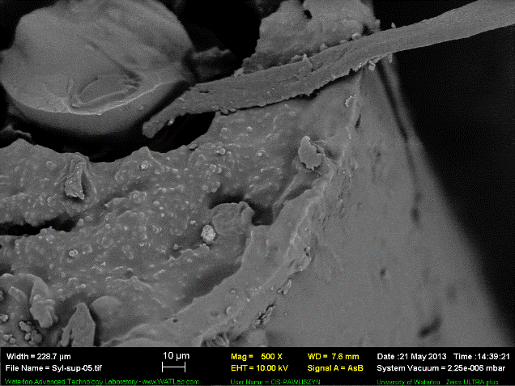
A
B
A
B
Figure S19 - SEM images of the PDMS-modified coatings: (A) Sylgard sealed end 200x magnification; (B) Partially sealed GC-PDMS end using 500x magnification.

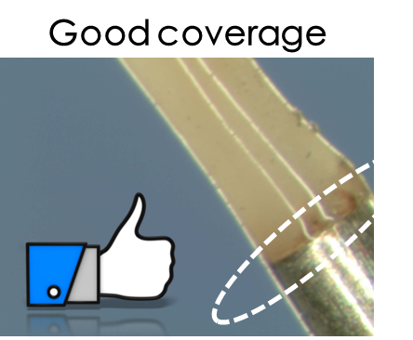
Figure S20 - Pictures depicting an effective PDMS overcoating of coating/metal junction.

