Supporting information
HIGH THROUGHPUT SOLID PHASE MICROEXTRACTION: A NEW ALTERNATIVE FOR ANALYSIS OF CELLULAR LIPIDOME?

Afsoon Pajand Birjandi¹, Barbara Bojko¹, Zhibin Ning², Daniel Figeys², Janusz Pawliszyn¹*

¹ Department of Chemistry, University of Waterloo, 200 University Avenue West, Waterloo, Ontario, N2L 3G1, Canada
² Ottawa Institute of Systems Biology, University of Ottawa, 451 Smyth Road, Ottawa, ON K1H 8M5, Canada

*Corresponding author. Tel.: +1-519-888-4641; Fax: +1-519-746-0435
E-mail address: janusz@uwaterloo.ca
#Present address: Department of Pharmacodynamics and Molecular Pharmacology, Faculty of Pharmacy, Collegium Medicum in Bydgoszcz, Nicolaus Copenicus University in Torun, dr A. Jurasza 2, 85-089 Bydgoszcz, Poland

SUMMARY
This Supporting Information file includes additional results and information as described in the text of the main article including 1) chemicals and materials, 2) cell culture, 3) preparation of C18-PAN 96-blade coatings, 4) data quality assurance, 5) LCMS method assessment, 6) quality control (QC) monitoring- assessment of instrumental response robustness, 7) feature identification, and 8) references.

Reagents and materials
LC-MS grade Methanol, acetonitrile, and 2-propanol (all HPLC gradient grade) were purchased from Fisher Scientific (ON, Canada). LC-MS grade acetic acid and ammonium acetate were obtained from Fluka (Sigma-Aldrich Oakville, ON, Canada). Two groups of lipid standard with even-numbered carbon chains (endogenous lipids), as well as odd-carbon acyl chains (non-endogenous) from each lipid class and subclass species were purchased from Avanti Polar Lipids (Alabaster, AL) for method development: 1-palmitoyl-2-hydroxy-sn-glycero-3-phosphocholine (LPC 16:0); 1-oleoyl-2-hydroxy-sn-glycero-3-phosphocholine (LPC 18:1); 1-myristoyl-2-stearoyl-sn-glycero-3-phosphocholine (PC 14:0/18:0); 1-stearoyl-2-arachidonoyl-sn-glycero-3-phosphocholine (PC 18:0/20:4); 1-palmitoyl-2-linoleoyl-sn-glycero-3-phosphoethanolamine (PE 16:0/18:2); N-oleoyl-D-erythro-sphingosylphosphorylcholine (SM d18:1/18:1); 1-(9Z-octadecenoyl)-rac-glycerol (MG 18:1(9Z)/0:0/0:0); 1,2,3-trihexadecanoyl-glycerol (TG 16:0/16:0/16:0); 1,3-di-(9Z-octadecenoyl)-2-hexadecanoyl-glycerol (TG 18:1/16:0/18:1); 1,2-distearoyl-sn-glycero-3-phospho-(1'-rac-glycerol) (PG 18:0/ 18:0); N-lauroyl-D-erythro-sphingosyl phosphorylcholine (SM d18:1/16:0); N-heptadecanoyl-D-erythro-sphingosine Ceramide (d17:1/17:0); 1-heptadecanoyl-rac-glycerol (MG 17:0); 1,2-diheptadecanoyl-sn-glycero-3-phospho-(1'-rac-glycerol) PG(17:0/17:0); 1,2-diheptadecanoyl-sn-glycero-3-phosphocholine (PC 17:0/17:0); 1,2-diheptadecanoyl-sn-glycero-3-phosphoethanolamine (PE 17:0/17:0); 1-heptadecanoyl-2-hydroxy-sn-glycero-3-phosphocholine (LPC 17:0); 1,2,3-triheptadecanoyl-glycerol (TG 17:0/17:0/17:0).

Preparation of C18-PAN 96-Blade coatings
For the high-throughput analysis of lipids, coated thin-film SPME blades were applied to plasma samples with the use of the manual Concept 96 (Professional Analytical System (PAS) Technology, Magdala, Germany). TF-SPME blades were made in house. For efficient immobilization of coating particles, the stainless steel surface was conditioned by sonication of blades in strong hydrochloric acid for approximately 60 min prior to the coating process. The blades were then rinsed thoroughly with nanopure water. Subsequently, they were dried in an oven for 30 min at 150 °C, then left to cool down to room temperature. A slurry of C18-PAN mixture was sprayed to immobilize C18 particles on the surface of stainless steel blades, followed by immediate thermal curing at 180 °C for 2 min; this identical coating-curing sequence were repeated 10 times for each blade in order to ensure uniform exposure and proper thickness of the C18-PAN coating on the surface of the blades. A comprehensive description of this method is given elsewhere [1]. In this study, the commercial mixed-mode SPME fibers were enclosed beside each pin in the 12 thin-film blade set. This assembly was designed to capture other polar metabolites from the same sample on the mixed-mode coatings, while lipids are captured by the C18 thin-film coatings. As the mix-mode coating has been previously reported as the most effective sorbent for the extraction of a range of highly polar to semi-nonpolar metabolites in metabolomic studies, [2–4] this enables any potential biomarkers to be tracked and related to probable metabolic pathways, if particular biomarkers were to be found.

Data Quality Assurance
The stability of the chromatographic system throughout the data acquisition phase was first examined through the PCA of global datasets (biological and QC samples) and confirmed by overlapping batches; clear spatial separation was found among different sample classes, regardless of the batch injection order and randomization. No instrument failure, indicating a decline in sensitivity, RT shifts, or changes in mass accuracy, was observed. The mass accuracy was assured by tracking the MS standard calibration every 24 hours.
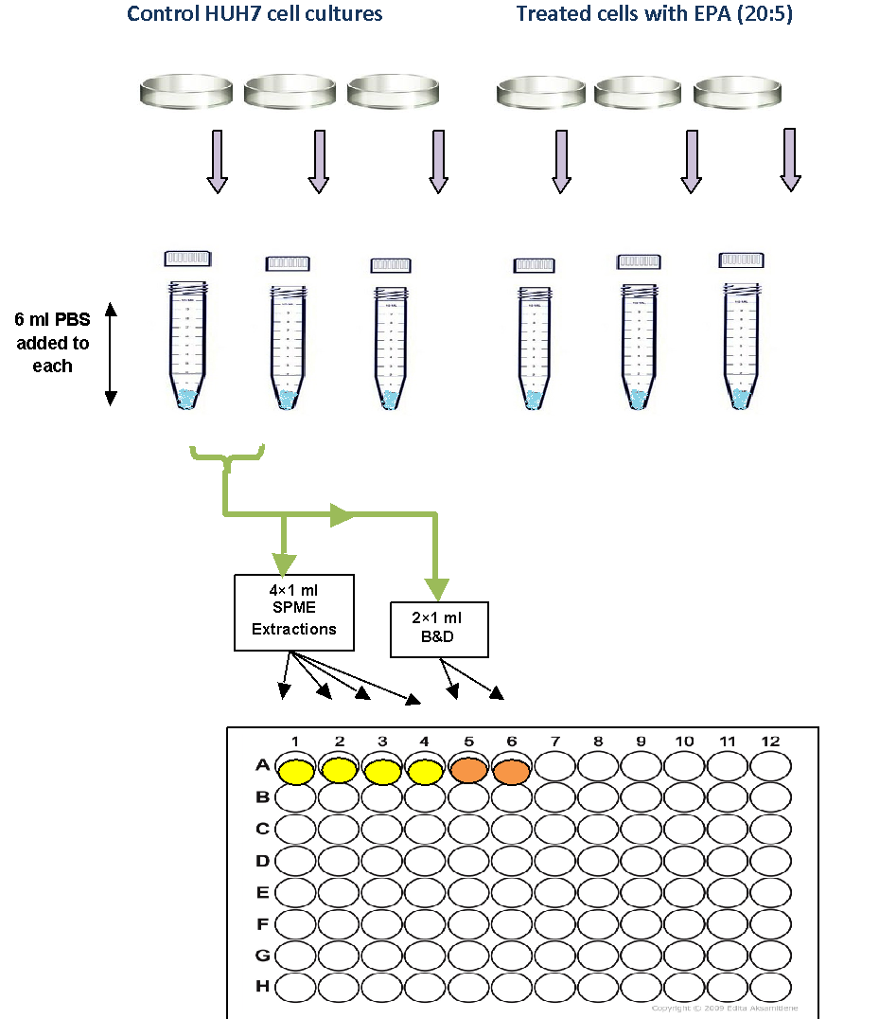
Figure S- 1 Schematic of sampling order for SPME and B&D procedure for cell suspension of HuH7; Each replicate tube contained approximately 8.4x10^6 cells; the experiment was repeated three times to obtain biological replicates

LCMS method assessment
The same set of odd lipid standards were employed for evaluation of retention time and mass intensity. As could be observed, lipids involved in the same sub-category could show different retention times due to differences in their fatty acyl chains.
Table S-1 Breakdown of lipid classes surveyed in the biostd with the use of the LC-MS system developed on the orbitrap mass spectrometer
Lipid class | Ionization polarity  Positive Negative |  | Retention time region (min)
Lysophospholipids (Lyso-) | [M+H]+ | - | 2-4
Phosphoethanolamine (PE) | [M+H]+ | - | 10-12
Phosphocholine (PC) | [M+H]+ | - | 11-13
Phosphoglycerol (PG) | [M+H]+ | [M-H]⁻ | 9-11
Ceramide (CE) | [M+H]+ | - | 12-14
Sphingomyelin (SM) | [M+H]+ | - | 9-12
Monoacylglycerol (MG) | [M+NH4]+ | - | 7-9
Diacylglycerol (DG) | [M+NH4]+ | - | 9-12
Triacylglycerol (TG) | [M+NH4]+ | - | 13-18
Cardiolipin (CL) | [M+NH4]+ | - | 15-20
Phosphoserine (PS) | - | [M-H]⁻ | 11-13
Phosphoinositol (PI) | - | [M-H]⁻ | 9-11
Fatty Acyls (FA) | - | [M-H]⁻ | 5-8
Upon analysis of standards of each lipid class and subclass, the “major adduct preference” with higher ionization intensity was determined and represented.

Sheath gas and auxiliary gas (arbitrary units), spray voltage (V), capillary temperature (°C), capillary voltage (V), tube lens voltage (V) and skimmer voltage (V) were set to 30, 10, 4000, 350, 50, 100, and 25 for positive ion mode and 55, 30, 3500, 275, -67, -85 and -24 for negative ion mode, respectively. Optimal separation was achieved using the following solvent gradient elution: Mobile B starts at 10%, remaining constant until minute 6, then increasing to 60% until minute 8, followed by a gradual increase to 70% B until minute 18, then ramping back to 10% for one minute, followed by four further minutes of column re-equilibration, for a total run time of 22 minutes. Quality control (QC) samples were prepared by pooling 10 μL aliquots of all sample extracts. Initially, 5 injections of blank and 10 injections of pooled QC were run for “system conditioning”.
- A) Standard Lipids in POSITIVE ion mode
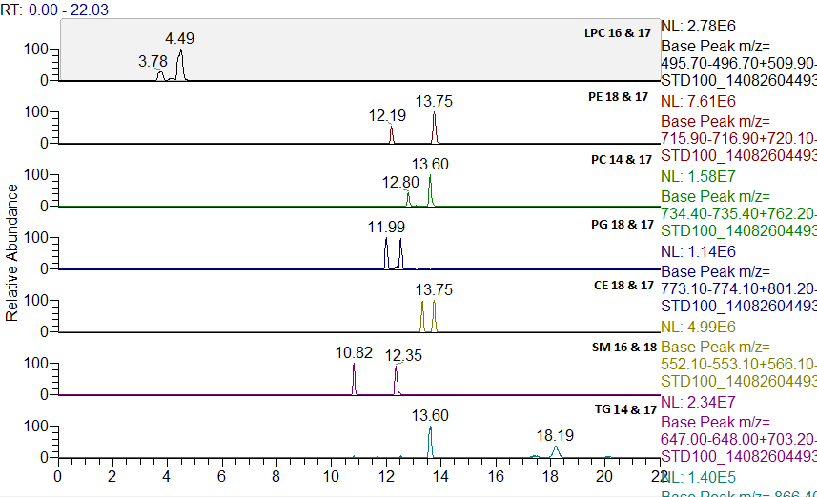
- B) Standard Lipids in NEGATIVE ion mode
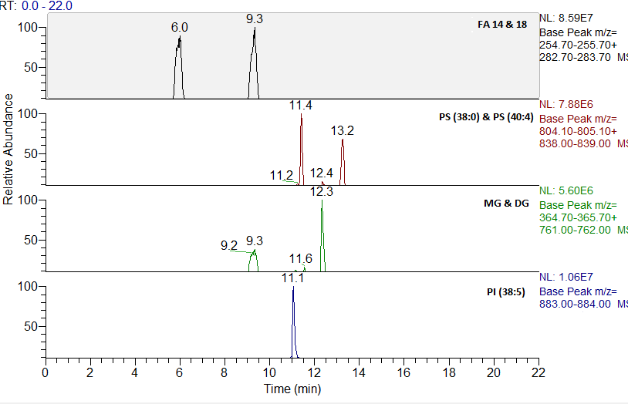
Figure S-2 XIC chromatogram of lipid standards in A) positive and B) negative ion mode. Variations in retention time are expected for lipids of the same class and sub-class dependent on their structural orientation and acyl chain length
Cell lipidome was profiled by injecting each sample once, in a well-considered randomized order, with periodic injection of blanks, QC, and standard lipid mixture throughout the sequence to evaluate system performance. This sample sequence yielded a total of 67 injections, each of which was run separately in positive and negative modes. The final validated LC-MS method is capable of analysing multiple categories of lipids in a single run with improved signal intensity and peak shape, while known ionization polarities and adduct preferences accommodate to confine the multiple hints when searching the ion feature against databases. Lipid standard solution and QC samples were frequently injected during the 24 hour sequence for each ion polarity. By placing these QC samples at regular intervals throughout the analytical run, LC-MS stability could be assessed, and any variation monitored in terms of relevant analytical parameters such as retention time, peak shape, peak intensity, and mass accuracy. Meanwhile, randomization of different biological replicates alternated with QCs allowed for the detection of systematic variability throughout the LC-MS measurement. The comparison of XIC of extracts obtained with both methods showed that signal to noise ratio was 30-50 times higher for Bligh & Dyer For instance, the calculated S/N of PE (35:0) with mz ratio of 720.59000 is 1682:1 for SPME, while this value for Bligh & Dyer is 58180:1. The observed discrepancy in signal intensity is related to the different nature of the two extraction methods. Bligh & Dyer is a liquid-liquid extraction method that exhaustively extracts all lipid components of cells, including bound and free lipid species, whilst SPME is a non-exhaustive extraction method that purely extracts lipids in their free (unbound) format. Therefore, as opposed to the B&D technique, lipids involved in complex cell structures, which are bound to proteins or particles of cell membrane are not extracted by SPME under conditions of negligible depletion extraction. It should be considered that high extraction recoveries in Bligh & Dyer may lead to saturation of the ESI source by most abundant phospholipids, therefore cause ionization suppression or enhancement and overload the chromatographic column and decrease its lifetime. On the other hand, higher signal intensities are indeed necessary and considered an advantage when the instrumental performance is substantial. In the LCMS method used for this research, all phospholipids were noted to elute between min 8-13, with retention times of various phospholipid subclasses varying based on their acyl moieties; in such cases, the possibility of co-elution, and consequently, saturation of ESI source is still significant.

Quality control (QC) Monitoring- assessment of instrumental response robustness
Quality control samples were prepared by combining aliquots of all samples, and injected frequently within the sample set. The results for this QC were used to ensure that no systematic drift occurred throughout the entire run time. Plots of signal intensity versus QC run order for known identified lipids for which authentic standards were available are shown in Figure S-3. Lipids were selected so as to cover a wide range of signal intensities and the entire chromatographic retention times. QC1, QC2, QC3 and QC4 were considered part of the preconditioning procedure, and were included to show that the system was adequately pre-conditioned. Figure S-3 shows a linear trend line for all QC injections for known lipids observed in the cell samples. The results indicate good performance of the entire LC-MS system. In addition to targeted monitoring of instrument response during a 24 hour run sequence for the selected lipids, QC samples were also used to assess the quality of global lipidomics data. This was performed by subjecting these QC samples to SIMCA processing into a PCA plot together with the entire treated and control cell samples extracted by both Bligh & Dyer and SPME. As can be seen, all QC injections (shown in yellow) cluster tightly together, with no evident outliers, which is a good indication of the quality of the data set. This verifies that the instrument response was robust throughout the entire sequence and further processing and interpretation of the dataset is reliable.

Figure S-3 Instrumental response variability for several QC injections randomized within the run sequence for selected compounds (a) CE, MG, and TG (b) SM and PE (c) PC and LPC; compounds with different signal intensity ranges are represented in separate charts

Feature Identification
A simple search of the Metlin and LIPID MAPS normally suggests multiple isobaric lipids for a single specific m/z ratio. A key criterion for narrowing down the selection is chromatographic retention time. Notably, lipids originally retain based on their hydrophobicity (LogP) and related acyl chain groups. Within the same lipid sub-group, retention time increases with acyl chain length and degree of saturation. Therefore, the retention time obtained for m/z value of 780.55338 that retained at min 11.40 could not possibly be a triglyceride, since all TG species retain after 13 min. Based on the validated LC/MS method, phospholipids solely produce [M+H]⁺ adduct ions in high intensities. This property eliminates the majority of the remaining alternatives and further refines the list. Since the accuracy of the mass spectrometry was strictly monitored, and the instrument frequently calibrated, a maximum ion tolerance on 5ppm could be confidently selected, which helped to remove plenty of hint results. For example, when searching for structures that corresponded to the unknown ion mass of 780.55338 obtained in positive ion mode, features within 0-5 ppm accuracy of the exact mass determined isobaric phospholipids that included 25 isomeric PC (36:5) species and 6 isomeric PE (39:5) species. The related peaks were inspected in the XIC chromatograms for reassurance. Figure S-4 illustrates the peak with mz ion of 962.72301, as one of the significant discriminative metabolites between control and treated cell samples which was detected by both SPME and B&D methods in positive ion mode.

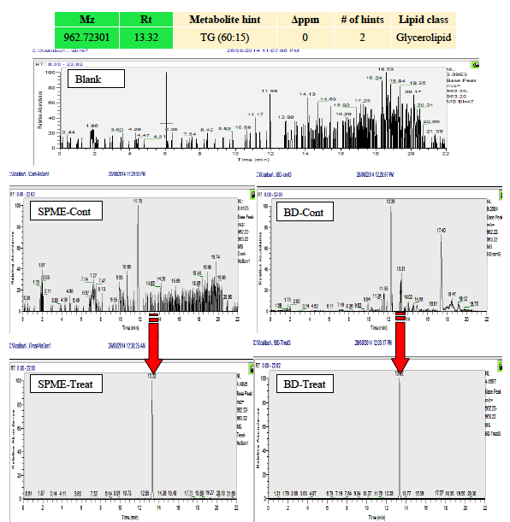

Figure S-4 Example XIC chromatograms illustrates the ion 962.72301 in control vs. treated groups using SPME and B&D. The chromatograms clearly confirm the changes of this species, which were not detectable in the control HUH7 cells cultured in normal condition. However, when the same cells were cultured while supplemented with EPA, this metabolite increased greatly and created a significant discrimination between cell groups in statistical analysis

Table S-2 List of upregulated lipids with use of SPME and Bligh & Dyer methods - positive mode
 | Up-regulated- Positive
 |  |  |  |  |  |  | Fold Change |  | VIP
 | Input mz | Exact mz | RT (min) | Metabolite | # of hits | Class | SPME | B&D | SPME | B&D
1 | 780.55338 | 780.5538 | 11.41 | PC (36:5) or PE (39:5) | 33 | Phospholipid | 56 | 23 | 4.35 | 10.33
2 | 806.56897 | 806.5694 | 11.36 | PC (38:6) or PE (41:6) | 37 | Phospholipid | 41 | 8 | 3.5 | 8.37
3 | 990.75424 | 990.7545 | 13.8 | TG (62:15) | 6 | Glycerolipid | 2566 | 291 | 3.01 | 7.93
4 | 268.99826 | - | 1.88 | Unidentified | - | - | 5 | ND | 6.22 | ND
5 | 146.01881 | - | 1.86 | Unidentified | - | - | 2 | ND | 5.67 | ND
6 | 522.35518 | 522.3554 | 3.59 | LPC(18:1) | 20 | Phospholipid | 10 | ND | 2.78 | ND
7 | 949.72522 | 949.728 | 16.08 | TG (60:13) | 14 | Glycerolipid | 3383 | 119 | 1.11 | 2.56
8 | 807.57242 | 807.5647 | 11.36 | PE (40:7) | 22 | Phospholipid | 43 | 8 | 2.48 | 6.01
9 | 854.56918 | 854.5694 | 10.71 | PC (42:10) | 9 | Phospholipid | 4653 | 64 | 2.37 | 7.01
10 | 834.60018 | 834.6007 | 11.72 | PC (40:6) or PE (43:6) | 30 | Phospholipid | 9 | 5 | 3.4 | 4.9
11 | 337.10448 | 337.107 | 2.17 | Isopsoralidin | 1 | Polyketide | 6 | ND | 2.02 | ND
12 | 962.72301 | 962.7232 | 13.32 | TG (60:15) | 2 | Glycerolipid | 3763 | 353 | 2.7 | 6.74
13 | 802.53533 | 802.5381 | 11.41 | PC (38:8) | 8 | Phospholipid | 56 | 28 | 1.86 | 1.57
14 | 778.53784 | 778.5381 | 10.87 | PC (36:6) or PE (39:6) | 28 | Phospholipid | 44 | 18 | 190 | 5.51
15 | 1018.78551 | 1018.7858 | 14.33 | TG (64:15) | 6 | Glycerolipid | 2822 | 299 | 1.68 | 4.69
16 | 808.58482 | 808.5851 | 11.79 | PC (38:5) or PE (41:5) | 36 | Phospholipid | 2 | 8 | 1.73 | 3.07
17 | 703.57479 | 703.5749 | 12.36 | PE-Cer(37:1) or SM(34:1) | 6 | Sphingolipid | 11 | ND | 1.66 | ND
18 | 766.57443 | 766.5745 | 11.79 | PC (36:4) | 18 | Phospholipid | 40 | 30 | 1.47 | 4.31
19 | 752.52239 | 752.5225 | 10.88 | PE (37:5) PC(34:5) | 23 | Phospholipid | 2 | 103 | 1.42 | 4.42
20 | 856.58486 | 856.5851 | 11.07 | PC (42:9) | 14 | Phospholipid | 116 | 67 | 1.01 | 3.29
21 | 942.75437 | 942.7545 | 15.26 | TG (58:11) | 28 | Glycerolipid | 3398 | 251 | 1.39 | 4.31
22 | 916.73863 | 916.7389 | 15.41 | TG (56:10) | 26 | Glycerolipid | 3939 | 220 | 1.36 | 4.25
23 | 764.55849 | 764.5589 | 11.64 | PC (36:5) | 6 | Phospholipid | 96 | 26 | 1.29 | 3.89
24 | 921.69405 | 921.6967 | 15.41 | TG (58:13) | 8 | Glycerolipid | 2989 | 111 | 1.26 | 3.12
25 | 764.52227 | 764.5225 | 11.46 | PE (38:6) or PC (35:6) | 31 | Phospholipid | 21 | 10 | 1.29 | 3.89
26 | 970.78556 | 970.7858 | 15.91 | TG (60:11) | 30 | Glycerolipid | 2165 | 175 | 1.23 | 3.58
27 | 944.76997 | 994.7702 | 16.08 | TG (58:10) | 38 | Glycerolipid | 786 | 188 | 1.21 | 3.71
28 | 882.60059 | 882.6007 | 11.05 | PC (44:10) | 6 | Phospholipid | 1799 | 214 | 1.19 | 4.29
29 | 804.55328 | 804.5538 | 10.92 | PC (36:4) PE (39:4) | 21 | Phospholipid | 112 | 4 | 1.11 | 3.08
30 | 768.55314 | 768.5538 | 12:59 | PE (38:4) or PC (35:4) | 51 | Phospholipid | 2 | ND | 1.19 | ND
31 | 738.50655 | 738.5068 | 11.51 | PE (36:5) or PC (33:5) | 24 | Phospholipid | 29 | 21 | 1.3 | <1
32 | 832.58469 | 832.5851 | 11:25 | PC (40:7) | 23 | Phospholipid | 17 | 4 | 1.01 | 2.85
33 | 792.58985 | 792.5902 | 11.71 | PC (38:5) | 19 | Phospholipid | 59 | 19 | 1.44 | 3.06
34 | 922.69748 | 922.7045 | 15.41 | TG (58:10) | 1 | Glycerolipid | 59 | 19 | 1.02 | 2.51
35 | 794.56952 | 794.5694 | 12.48 | PE (40:5) or PC (37:5) | 40 | Phospholipid | 4 | 3 | 1.97 | 2.7
36 | 750.5425 | 750.5432 | 12.16 | PE (38:5) | 15 | Phospholipid | 5 | 3 | 1.16 | 1.95
37 | 828.5535 | 828.5538 | 10.73 | PC (40:9) | 12 | Phospholipid | 295 | 96 | 1.44 | 4.29
38 | 480.30832 | 480.3085 | 3.83 | Lyso PE (18:1) | 3 | Phospholipid | 5 | ND | 1.01 | ND
39 | 721.50641 | 721.5014 | 13.39 | PG (32:1) | 14 | Phospholipid | 5 | ND | 1.01 | ND

 | Up-regulated- Positive
 |  |  |  |  |  |  | Fold Change |  | VIP
 | Input mz | Exact mz | RT (min) | Metabolite | # of hits | Class | SPME | B&D | SPME | B&D
1 | 780.55338 | 780.5538 | 11.41 | PC (36:5) or PE (39:5) | 33 | Phospholipid | 56 | 23 | 4.35 | 10.33
2 | 806.56897 | 806.5694 | 11.36 | PC (38:6) or PE (41:6) | 37 | Phospholipid | 41 | 8 | 3.5 | 8.37
3 | 990.75424 | 990.7545 | 13.8 | TG (62:15) | 6 | Glycerolipid | 2566 | 291 | 3.01 | 7.93
4 | 268.99826 | - | 1.88 | Unidentified | - | - | 5 | ND | 6.22 | ND
5 | 146.01881 | - | 1.86 | Unidentified | - | - | 2 | ND | 5.67 | ND
6 | 522.35518 | 522.3554 | 3.59 | LPC(18:1) | 20 | Phospholipid | 10 | ND | 2.78 | ND
7 | 949.72522 | 949.728 | 16.08 | TG (60:13) | 14 | Glycerolipid | 3383 | 119 | 1.11 | 2.56
8 | 807.57242 | 807.5647 | 11.36 | PE (40:7) | 22 | Phospholipid | 43 | 8 | 2.48 | 6.01
9 | 854.56918 | 854.5694 | 10.71 | PC (42:10) | 9 | Phospholipid | 4653 | 64 | 2.37 | 7.01
10 | 834.60018 | 834.6007 | 11.72 | PC (40:6) or PE (43:6) | 30 | Phospholipid | 9 | 5 | 3.4 | 4.9
11 | 337.10448 | 337.107 | 2.17 | Isopsoralidin | 1 | Polyketide | 6 | ND | 2.02 | ND
12 | 962.72301 | 962.7232 | 13.32 | TG (60:15) | 2 | Glycerolipid | 3763 | 353 | 2.7 | 6.74
13 | 802.53533 | 802.5381 | 11.41 | PC (38:8) | 8 | Phospholipid | 56 | 28 | 1.86 | 1.57
14 | 778.53784 | 778.5381 | 10.87 | PC (36:6) or PE (39:6) | 28 | Phospholipid | 44 | 18 | 190 | 5.51
15 | 1018.78551 | 1018.7858 | 14.33 | TG (64:15) | 6 | Glycerolipid | 2822 | 299 | 1.68 | 4.69
16 | 808.58482 | 808.5851 | 11.79 | PC (38:5) or PE (41:5) | 36 | Phospholipid | 2 | 8 | 1.73 | 3.07
17 | 703.57479 | 703.5749 | 12.36 | PE-Cer(37:1) or SM(34:1) | 6 | Sphingolipid | 11 | ND | 1.66 | ND
18 | 766.57443 | 766.5745 | 11.79 | PC (36:4) | 18 | Phospholipid | 40 | 30 | 1.47 | 4.31
19 | 752.52239 | 752.5225 | 10.88 | PE (37:5) PC(34:5) | 23 | Phospholipid | 2 | 103 | 1.42 | 4.42
20 | 856.58486 | 856.5851 | 11.07 | PC (42:9) | 14 | Phospholipid | 116 | 67 | 1.01 | 3.29
21 | 942.75437 | 942.7545 | 15.26 | TG (58:11) | 28 | Glycerolipid | 3398 | 251 | 1.39 | 4.31
22 | 916.73863 | 916.7389 | 15.41 | TG (56:10) | 26 | Glycerolipid | 3939 | 220 | 1.36 | 4.25
23 | 764.55849 | 764.5589 | 11.64 | PC (36:5) | 6 | Phospholipid | 96 | 26 | 1.29 | 3.89
24 | 921.69405 | 921.6967 | 15.41 | TG (58:13) | 8 | Glycerolipid | 2989 | 111 | 1.26 | 3.12
25 | 764.52227 | 764.5225 | 11.46 | PE (38:6) or PC (35:6) | 31 | Phospholipid | 21 | 10 | 1.29 | 3.89
26 | 970.78556 | 970.7858 | 15.91 | TG (60:11) | 30 | Glycerolipid | 2165 | 175 | 1.23 | 3.58
27 | 944.76997 | 994.7702 | 16.08 | TG (58:10) | 38 | Glycerolipid | 786 | 188 | 1.21 | 3.71
28 | 882.60059 | 882.6007 | 11.05 | PC (44:10) | 6 | Phospholipid | 1799 | 214 | 1.19 | 4.29
29 | 804.55328 | 804.5538 | 10.92 | PC (36:4) PE (39:4) | 21 | Phospholipid | 112 | 4 | 1.11 | 3.08
30 | 768.55314 | 768.5538 | 12:59 | PE (38:4) or PC (35:4) | 51 | Phospholipid | 2 | ND | 1.19 | ND
31 | 738.50655 | 738.5068 | 11.51 | PE (36:5) or PC (33:5) | 24 | Phospholipid | 29 | 21 | 1.3 | <1
32 | 832.58469 | 832.5851 | 11:25 | PC (40:7) | 23 | Phospholipid | 17 | 4 | 1.01 | 2.85
33 | 792.58985 | 792.5902 | 11.71 | PC (38:5) | 19 | Phospholipid | 59 | 19 | 1.44 | 3.06
34 | 922.69748 | 922.7045 | 15.41 | TG (58:10) | 1 | Glycerolipid | 59 | 19 | 1.02 | 2.51
35 | 794.56952 | 794.5694 | 12.48 | PE (40:5) or PC (37:5) | 40 | Phospholipid | 4 | 3 | 1.97 | 2.7
36 | 750.5425 | 750.5432 | 12.16 | PE (38:5) | 15 | Phospholipid | 5 | 3 | 1.16 | 1.95
37 | 828.5535 | 828.5538 | 10.73 | PC (40:9) | 12 | Phospholipid | 295 | 96 | 1.44 | 4.29
38 | 480.30832 | 480.3085 | 3.83 | Lyso PE (18:1) | 3 | Phospholipid | 5 | ND | 1.01 | ND
39 | 721.50641 | 721.5014 | 13.39 | PG (32:1) | 14 | Phospholipid | 5 | ND | 1.01 | ND

Table S-3 List of up-regulated lipids obtained with use of SPME and Bligh & Dyer methods -negative mode

Up-regulated-Negative
 |  |  |  |  |  |  | Fold Change |  | VIP
 | Input mz | Exact mz | RT (min) | Metabolite | # of hits | Class | SPME | B&D | SPME | B&D
1 | 301.21768 | 301.2173 | 3.23 | EPA (20:5) | 13 | Fatty acid | 356 | 219 | 20.1 | 15.4
2 | 283.26453 | 283.2643 | 9.34 | Stearic Acid (18:0) | 25 | Fatty acid | 4 | 1 | 4.94 | 7.14
3 | 255.23317 | 255.233 | 5.85 | Palmitic acid (16:0) | 32 | Fatty acid | 6 | 1 | 4.56 | 6.5
4 | 329.24916 | 329.2486 | 4.15 | DPA (22:5) | 8 | Fatty acid | 28 | 28 | 7.61 | 6.01
5 | 331.26493 | 331.2643 | 5.41 | Adrenic acid (22:4) | 12 | Fatty acid | 13 | 1 | 1.11 | 1.01
6 | 281.24898 | 281.2486 | 6.19 | Oleic acid (18:1) | 69 | Fatty acid | 11 | 1 | 2.38 | 1.93
7 | 303.23346 | 303.233 | 4.02 | Arachidonic acid (20:4) | 67 | Fatty acid | 4 | 1 | 1.3 | 2.35
8 | 311.2963 | 311.2956 | 10.86 | Fatty ester (20:0) | 26 | Fatty acid | 5 | 1 | 1.01 | 1.59
9 | 279.23341 | 279.233 | 4.48 | Lineolic acid (18:2) | 168 | Fatty acid | 4 | 1 | 2.1 | 1.44
10 | 253.21765 | 253.2173 | 4.21 | palmitoleic acid (16:1) | 65 | Fatty acid | 5 | ND | 1.88 | ND
11 | 818.59427 | 818.5917 | 12.72 | PS (38:1) | 7 | Phospholipid | 4 | 1 | 1.02 | 2.33
12 | 883.53685 | 883.5342 | 10.97 | PI (38:5) | 28 | Phospholipid | 3 | 3 | 1.1 | 2.42
13 | 885.55254 | 885.5499 | 11.35 | PI (38:4) | 24 | Phospholipid | 8 | ND | 1.03 | 2.75
14 | 892.61004 | 892.6073 | 11.72 | PS (44:5) | 2 | Phospholipid | 9 | 7 | 1.01 | 1.52
15 | 866.59438 | 866.5917 | 11.79 | PS (42:4) | 8 | Phospholipid | 5 | ND | 1.04 | ND
16 | 894.62626 | 894.623 | 12.37 | PS (44:4) | 3 | Phospholipid | 3 | ND | 1.01 | ND
17 | 749.53427 | 794.5338 | 12.16 | PG (34:0) | 11 | Phospholipid | 6 | ND | 1.02 | ND
18 | 875.58528 | 875.5808 | 12.82 | PG (44:7) | 2 | Phospholipid | 9 | ND | 1.02 | ND
19 | 838.56301 | 838.5604 | 11.41 | PS (40:4) | 14 | Phospholipid | 48 | 36 | 1.05 | 3.06
20 | 804.61491 | 804.6124 | 13.28 | PS (38:0) | 3 | Phospholipid | 5 | 5 | 1.01 | 1.48
21 | 793.56064 | 793.5753 | 12.49 | PA (43:4) | 2 | Phospholipid | 8 | ND | 1.02 | ND
22 | 761.58353 | 761.5702 | 12.37 | PG (36:0) | 6 | Phospholipid | 10 | ND | 1.07 | ND
23 | 844.60968 | 844.6073 | 12.61 | PS (40:1) | 8 | Phospholipid | 7 | 1 | 1.06 | 2.14
24 | 886.55604 | 886.5604 | 11.35 | PS (44:8) | 3 | Phospholipid | 6 | 2 | 1.01 | 1.95

Table S-4 List of down-regulated lipids obtained with use of SPME and Bligh & Dyer methods -positive mode
 | Down-regulated - Positive
 |  |  |  |  |  |  | Fold Change |  | VIP
 | Input mz | Exact mz | RT (min) | Metabolite | # of hits | Class | SPME | B&D | SPME | B&D
1 | 786.60055 | 786.6007 | 12.6 | PC (36:2) or PE (39:2) | 82 | Phospholipid | 2 | 10 | 2.66 | 7.3
2 | 760.58459 | 760.5861 | 12.71 | PE (37:1) or PC (34:1) | 47 | Phospholipid | ND | 5 | ND | 6.42
3 | 788.61603 | 788.6164 | 13.46 | PC (36:1) or PE (39:1) | 55 | Phospholipid | ND | 3 | ND | 5.52
4 | 782.56924 | 782.5694 | 11.85 | PC (36:4) or PE (39:4) | 60 | Phospholipid | ND | 8 | ND | 5.2
5 | 678.50661 | 678.5068 | 11.48 | PC (28:0) or PE (31:0) | 32 | Phospholipid | ND | 4 | ND | 3.1
6 | 758.56889 | 758.5694 | 12.07 | PE (37:1) or PC (34:1) | 68 | Phospholipid | ND | 6 | ND | 3.27
7 | 732.55333 | 732.5538 | 12.06 | PE (35:1) or PC (32:1) | 40 | Phospholipid | 5 | 5 | 1.79 | 5.27
8 | 794.72296 | 794.7232 | 18.98 | TG (46:1) | 28 | Glycerolipid | 4 | 3 | 1.97 | 2.7
9 | 822.75435 | 822.7545 | 20.23 | TG (48:1) | 60 | Glycerolipid | 3 | 2 | 2.04 | 1.01
10 | 617.51151 | 617.514 | 13.87 | DG (34:1) | 14 | Glycerolipid | 5 | ND | 1.04 | ND
11 | 468.30841 | 468.3085 | 2.83 | LysoPC (14:0) | 1 | Phospholipid | 3 | ND | 1.01 | ND
12 | 627.5345 | 627.4983 | 11.34 | DG (37:6) | 4 | Glycerolipid | 3 | 3 | 1.03 | 3.75
13 | 730.53777 | 730.5381 | 11:49 | PE (35:2) or PC (32:2) | 32 | Phospholipid | 3 | 9 | 1.01 | 4.53
14 | 761.58805 | 761.5691 | 12.71 | PG (20:3) | 5 | Phospholipid | 5 | ND | 2.58 | ND
15 | 772.58445 | 772.5851 | 12.27 | PC (35:2) | 56 | Phospholipid | 2 | 9 | 1.01 | 2.46
16 | 704.52201 | 704.5225 | 11.44 | PE (33:1) or PC (30:1) | 29 | Phospholipid | 3 | 3 | 1.24 | 3.41
17 | 1279.35114 |  | 17.47 | Unidentified | - | - | 3 | ND | 2.49 | ND
18 | 1205.33235 |  | 16.69 | Unidentified | - | - | 3 | ND | 2.69 | ND
19 | 687.19942 |  | 12.58 | Unidentified | - | - | 21 | 3 | 2.57 | 1.01

 | Down-regulated - Positive
 |  |  |  |  |  |  | Fold Change |  | VIP
 | Input mz | Exact mz | RT (min) | Metabolite | # of hits | Class | SPME | B&D | SPME | B&D
1 | 786.60055 | 786.6007 | 12.6 | PC (36:2) or PE (39:2) | 82 | Phospholipid | 2 | 10 | 2.66 | 7.3
2 | 760.58459 | 760.5861 | 12.71 | PE (37:1) or PC (34:1) | 47 | Phospholipid | ND | 5 | ND | 6.42
3 | 788.61603 | 788.6164 | 13.46 | PC (36:1) or PE (39:1) | 55 | Phospholipid | ND | 3 | ND | 5.52
4 | 782.56924 | 782.5694 | 11.85 | PC (36:4) or PE (39:4) | 60 | Phospholipid | ND | 8 | ND | 5.2
5 | 678.50661 | 678.5068 | 11.48 | PC (28:0) or PE (31:0) | 32 | Phospholipid | ND | 4 | ND | 3.1
6 | 758.56889 | 758.5694 | 12.07 | PE (37:1) or PC (34:1) | 68 | Phospholipid | ND | 6 | ND | 3.27
7 | 732.55333 | 732.5538 | 12.06 | PE (35:1) or PC (32:1) | 40 | Phospholipid | 5 | 5 | 1.79 | 5.27
8 | 794.72296 | 794.7232 | 18.98 | TG (46:1) | 28 | Glycerolipid | 4 | 3 | 1.97 | 2.7
9 | 822.75435 | 822.7545 | 20.23 | TG (48:1) | 60 | Glycerolipid | 3 | 2 | 2.04 | 1.01
10 | 617.51151 | 617.514 | 13.87 | DG (34:1) | 14 | Glycerolipid | 5 | ND | 1.04 | ND
11 | 468.30841 | 468.3085 | 2.83 | LysoPC (14:0) | 1 | Phospholipid | 3 | ND | 1.01 | ND
12 | 627.5345 | 627.4983 | 11.34 | DG (37:6) | 4 | Glycerolipid | 3 | 3 | 1.03 | 3.75
13 | 730.53777 | 730.5381 | 11:49 | PE (35:2) or PC (32:2) | 32 | Phospholipid | 3 | 9 | 1.01 | 4.53
14 | 761.58805 | 761.5691 | 12.71 | PG (20:3) | 5 | Phospholipid | 5 | ND | 2.58 | ND
15 | 772.58445 | 772.5851 | 12.27 | PC (35:2) | 56 | Phospholipid | 2 | 9 | 1.01 | 2.46
16 | 704.52201 | 704.5225 | 11.44 | PE (33:1) or PC (30:1) | 29 | Phospholipid | 3 | 3 | 1.24 | 3.41
17 | 1279.35114 |  | 17.47 | Unidentified | - | - | 3 | ND | 2.49 | ND
18 | 1205.33235 |  | 16.69 | Unidentified | - | - | 3 | ND | 2.69 | ND
19 | 687.19942 |  | 12.58 | Unidentified | - | - | 21 | 3 | 2.57 | 1.01

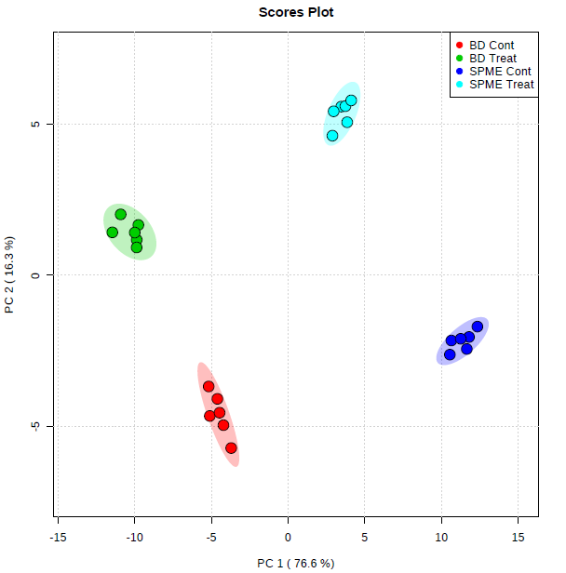
Figure S- 5 Score plots of PCA performed on the lipid features of most significant difference. Plot illustrates a clear separation between B&D-control (red) and SPME-control (dark blue), B&D-Treat (green) and SPME-Treat (light blue). The x-axes and y-axes represent the score of the first and second principal component contributing 72.6% and 20.3% variances, respectively.

References
- F. S. Mirnaghi, Y. Chen, L. M. Sidisky, J. Pawliszyn, Optimization of the coating procedure for a high-throughput 96-blade solid phase microextraction system coupled with LC-MS/MS for analysis of complex samples, Anal. Chem. 83 (2011) 6018–6025.
- D. Vuckovic, J. Pawliszyn, Systematic evaluation of solid-phase microextraction coatings for untargeted metabolomic profiling of biological fluids by liquid chromatography-mass spectrometry, Anal. Chem. 83 (2011) 1944–1954.
- D. Vuckovic, I. de Lannoy, B. Gien, R. E. Shirey, L. M. Sidisky, S. Dutta, J. Pawliszyn, In vivo solid-phase microextraction: capturing the elusive portion of metabolome, Angew. Chem. Int. Ed. Engl. 50 (2011) 5344–5348.
- D. Vuckovic, S. Risticevic, J. Pawliszyn, In vivo solid-phase microextraction in metabolomics: opportunities for the direct investigation of biological systems, Angew. Chem. Int. Ed. Engl. 50 (2011) 5618–5628.

