Development of a Multichannel Microfluidic System with Schlieren Imaging Microscopy for Online Chip-Based Moving Boundary Electrophoresis
Atefeh S. Zarabadi¹, Janusz Pawliszyn^{*1}, Mojtaba Hajialamdari²
¹Department Of Chemistry, University Of Waterloo, Waterloo, Ontario, Canada N2l 3G1
²Department of Physics and Astronomy, University Of Waterloo, Waterloo, Ontario, Canada N2l 3G1
*E-mail: janusz@uwaterloo.ca Phone: 519-888-4567 x35123

Keywords: Capillary isoelectric focusing; Concentration gradient detection; Moving Boundary Electrophoresis; Multichannel Chip; Schlieren imaging microscopy.
Schlieren Set-up
The system was mounted on a vibration isolation table. The components were arranged as outlined in Figure S-1, and fine adjustments were precisely performed. The light was accurately focused so as to avoid aberrations and misalignment of the optical components, and each of the components was carefully aligned to pass the light without interferences or distortion. After optimization of the positions and appropriate alignment, the system was rotated to the vertical configuration.
The system implemented a beam-expander lens to expand the green laser (532 nm, power ≤5 mW) beam to a 5cm-diameter light spot, and was equipped with filters and a pinhole to adjust to a desired spot diameter and lower the power. The collimated light traversed another lens (L1) to reach the test area, where the chip was located. Depending on the experiment, the light was deflected by or straightly passed through the Schlieren lens (L2); those rays that were not deflected would focus at the Stop and were blocked there, while the rays that were deflected by the sample inside the channel changed their path and reached the camera. The deflected beams were focused and hit the sensor via the image transfer lens (L3).
Test Area

Figure S-1 The Schlieren set-up, and the ray traverse path: The laser beams were expanded and illuminated on the multi-channel chip (M.C.) in the test area, then blocked by the Stop (K) from reaching the camera. As the light deflected from its focal point by changes in the concentration, the beams hit the CCD sensor.

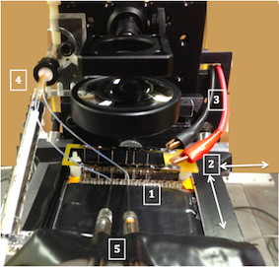
Figure S-2 Multi-channel chip in Schlieren test area: (1) the chip with electrode comb (2) xy-axis 2D adjustment (3) connectors to the high power supply (4) plastic tube to remove the electrolyte by vacuum (5) micro-syringes for sample introduction.
A CCD camera captured images. Lenses 1 and 2 were 5-cm-diameter, with 7.5-cm and 2.5-cm focal lengths, respectively. The third lens was a 2.5-cm-diameter plano-convex lens that converged the beams passing through the Stop plate on the CCD sensor. The specific characteristics of laser, such as its monochromaticity, intensity, and coherence, make it a proper choice for this study. However, the light intensity of the laser beam is at its maximum in the middle, and decreasing as it gets further from the center, which results in a Gaussian distribution. This inhomogeneity in the beam spot profile was corrected by putting a mechanical aperture in front of the light source, in order to selectively pick from the center of the beam spot. Additionally, a graded neutral density filter was used to minimize inhomogeneity, and attenuate the light intensity to avoid camera saturation.
The laser beam was first expanded to a 5-cm-diameter spot; this allowed covering the view field of the camera, which is illumination of the laser to five channels at the time. The channels experienced different light intensities, according to their position in the laser beam spot. In order to minimize the inconsistencies caused by this situation, the experimental region was limited to the center of the light spot. The mechanical aperture provides illumination to the desired channel/channels by adjusting the pinhole size.
CE Techniques
Capillary Isoelectric Focusing; Static Mode
The effective separation path length was 5 cm in the capillary, and 3 cm in the channel. The capillary dimension was 100 μm ID, and 200 μm OD with fluorocarbon internal coating. Channel C was a square duct with a 100 μm width. Sodium hydroxide (100 mM) and phosphoric acid (100 mM) were used as the catholyte and anolyte, respectively. The sample mixture contains a 0.5 $\frac{mg}{mL}$ myoglobin, 0.35% w/v methylcellulose, 2% v/v Pharmalyte 3-10 and 6-8. The focusing was performed at 1.5 kV for 2 min, followed by 3 kV until it reached a stable focusing, which often took less than 10 min in total. In this mode, the sample components are separated based on their isoelectric points and the diffusion process is recorded statically, that is, in the absence of an electric field or any other driving force.
Moving Boundary Electrophoresis; Dynamic Mode
The whole system was mounted in the testing region of the Schlieren set-up. All samples were dissolved in buffers before use. Tryptophan 1 mg/ml in borate buffer (50 mM, pH 10), and BSA 1 mg/ml in phosphate buffer (40 mM, pH 2.5), were used as samples. Basically, no separation happens in this mode and the dispersion of the moving front is dynamically recorded to estimate the molecular diffusion coefficient. First, each reservoir and the desired channels were filled with buffer.
The capillary cartridge was conditioned with 0.5% w/v methylcellulose solution to minimize the EOF, whereas the polymeric channels on the chip were merely flushed with water between runs. Protein adsorption to the channel walls was investigated with this chip, showing negligible wall interaction. Due to their hydrophobic nature, plastic microchips, especially COC chips, have very low EOF rates. Since the COC linear channel is resistant to a wide range of polar solvents and molecules, it is almost inert, avoiding electroosmotic flow. However, the EOF is not necessarily zero. Having negligible wall interaction, the polymeric chip is suitable for performing IEF without conditioning the column.
Chip Specifications and Configurations
Basically the chip comprises three layers, and an additional photo-mask layer was attached at the bottom: 1) Top layer: a rigid polymer containing electrolyte reservoir and through holes between the electrolyte reservoirs and separation channel, with slide standard ports 2) Middle & bottom layers: parallel separation channels, and a rigid polymer foundation 3) Photo-mask layer: black glass sheet with slits aligned with the channels
In contrast to the conventional metal slit that is used in commercial capillary cartridges to avoid stray light, which is expensive and tedious to align in the case of capillary arrays, the photo-mask layer boasts the inherent advantage of aligning the slit layer to parallel channels in one step. The pattern of the slide is plotted by AutoCAD software and printed as a photo-mask by the Front Range Photo Mask Company in USA. This layer was aligned with channels and attached to the bottom of the slide, using epoxy glue, under the microscope. The ease of this one-step multiple alignment, together with the lower cost of purchase in comparison to the metal slit for UV-detection method, are worthy of note. The Pt. electrodes of the instrument were also replaced with longer ones to reach the newly designed reservoirs. A membrane was needed to facilitate the electrolyte ion passage. The membrane was provided in the form of a nitrocellulose hollow fiber, which was inserted between two pieces of fused silica capillary. The shorter capillary piece, in contact with the channel port, was 6 mm long that comprised the connector fused silica capillaries on either side of the channel to the 18 mm long channel, making a separation column 3 cm long in total, with a 1.8 cm effective length of channel as the detection window. Using a standard thinXXS Adaptor that was drilled by the machine shop at University of Waterloo to accommodate a fused silica capillary, this adapter was mechanically joined with the COC slide. A micropipette tip of 100μL capacity was glued on top of the standard port. A metal slit of 100 μm wide was aligned to channel C to stop stray light.

The capillary-to-chip interface was important from the viewpoint of the dead volume, which affected the reproducibility and proper formation of the pH gradient. Using the connector directly to the inlet result in an empty space, which was modified in order to avoid dead-volume- associated issues. The interface was a connector, which was manipulated utilizing an attached micropipette tapered tip, providing a modified sealed connection to minimize dead volume issues.
Data Acquisition Setting
Figure S-3 The prototype COC slide layout, and modifications. The slide with a footprint of 7.5 x 2.5 (cm²) has 8 short channels of 18mm with different cross sectional areas. Photo-mask layer: black glass sheet with slits aligned with the channels. Electrode comb: a set of Pt wires to establish simultaneous electric field.
Movies were obtained by sequential display of the frames recorded at specific intervals. The minimum time required for an acquisition depends on a number of factors, including the exposure time, number of accumulations, kinetic series length, and the kinetic cycle time. These parameters were defined and set to the following values for all MBE/Schlieren experiments:
- Exposure time: the time interval during which the camera collects light for a single scan (Set to 0.1 sec).
- Number of accumulation: the number of scans that are added (or averaged) to produce a single frame of the processed data series (Set to 3).
- Kinetic series length: the number of frames in the entire data series (Set to 100-150).
- Kinetic cycle time: the time interval between the frames (Equal to 1 sec.).
The data was collected in a kinetic series with 100 scans; each scan consisted of three accumulations with 0.3 sec cycle, hence the frequency of 0.98 Hz was obtained, which equals to 1 frame per second.
Distance from anode (pixel)
Distance from anode (pixel)
Absorbance at 280nm
Absorbance at 280nm
Figure S-4 Evaluation of the multi-channel chip (D_{H}=100 μm, Length=3 cm (1.8 cm detection window)) in comparison with commercial capillary cartridge (ID=100 μm, Length=5 cm), through CIEF experiment of myoglobin isoforms with UV-WCID. Myoglobin pI markers (pI 6.8 and 7.2, 0.5 mg/mL) with a carrier ampholyte at pH gradient 3-10 and 6-8 for the chip and capillary respectively. Applied voltage; 1.5 kV for 2 min, and 3 kV for 7 min.
CIEF with UV-WCID
The COC multi-channel chip was examined by CIEF-UV-WCID; different parameters such as reproducibility, resolution, and wall-interaction were compared to those of the commercial capillary cartridge. And properties of the multi-channel slide for chip-based electrophoresis analysis have been investigated by UV whole column imaging detection. Short channels or capillaries are required in order to image the whole separation column. In conventional single point detection, long capillaries are used, and shallow pH gradients are generated as a result. The concern about decrease in resolution due to using short capillary was theoretically addressed by Mao and Pawliszyn ². They have considered concentration of a sample zone focused in a capillary by the isoelectric focusing process as a Gaussian distribution with a variance of σ², and relate it to the resolution, using the criterion of three times the variance for resolved adjacent peaks. Hence, the resolving power (Δ pI) can be expressed as ³:
$$ΔpI=\sqrt{\frac{D}{E}\frac{d(pH)}{-dμ}\frac{d(pH)}{dx}}$$
The equation shows that good resolution (small Δ pI) is obtained by a strong electric field, a low diffusion coefficient, a high mobility slope, $\frac{dμ}{d(pH)}$ , and a narrow pH gradient. Improving the resolution is possible through variation of the field strength and pH gradient, because the diffusion coefficient and the mobility slope are intrinsic properties of the analytes. Efficient heat dissipation is necessary for applying high voltages, which is acquired by employing narrow-bore fused silica capillaries. Therefore, the resolution is independent of the length of the separation column, however considering the Joule heating issue; it is related to the surface-to-volume-ratio of the separation column. Thus, miniaturizing the column can happen without sacrificing resolution in capillary isoelectric focusing. A number of advantages are associated with using a short column; for example, the capillary isoelectric focusing experiment will perform faster in a short column. The whole separation column can be imaged by a charge-coupled device camera detector, which facilitates the study of dynamic processes. Sample consumption will be reduced in a short column, because the mixture of sample and carrier ampholytes usually fills the whole column, and requires a lager amount of the sample in a long column.
Evaluation of the Multi-channel Chip
In order to investigate the resolving capability of the chip, a mixture of two myoglobin pI markers (pI 6.8 and 7.2, 0.5 $\frac{mg}{mL}$ ) with a carrier ampholyte at pH gradient range from 6 to 8 was introduced into the separation channel that generates the pH gradient of $\frac{d(pH)}{dx}$ ≈ 0.7 ($\frac{pH Unit }{cm}$). In the capillary cartridge, a longer column (5 cm) and a wider pH range (3-10) create a pH gradient of 1.4 ($\frac{pH Unit }{cm}$), which is two-fold greater than that of the COC-chip gradient. The choice of carrier ampholyte range influences the generated pH gradient and the resolution. For example, a high resolution of ≈0.03 pH units can be achieved in a 5-cm-long capillary performed with imaged CIEF, when a narrow pH gradient of 6 to 8 with a high voltage of 3 kV is used ⁴. In this experiment, focusing was performed at 1.5 kV for 2 min, followed by 3 kV for 7 more minutes. Under the employed conditions, shallower pH gradient was formed in the multi-channel chip that has positively contributed in the resolving power of the separation experiment.
A comparison of the separation experiments in the COC-chip and the commercial chip, as demonstrated in Figure S-4, showed that the myoglobin isoforms were fairly well resolved in both devices. However, the corresponding peaks were broader for the COC chip, thus suggesting analyte wall adsorption. Due to the inert surface of the plastic chip, its channel preconditioning for EOF suppression was not as important, compared to the fused silica in the commercial cartridge. Hence, flushing with water between runs was adequate to get reproducible data. A relative standard deviation of 1.8% for determination of the peak positions in three trials showed lower but comparable reproducibility to the similar experiment in the commercial channel.
Lens Effect; Geometry of the Column
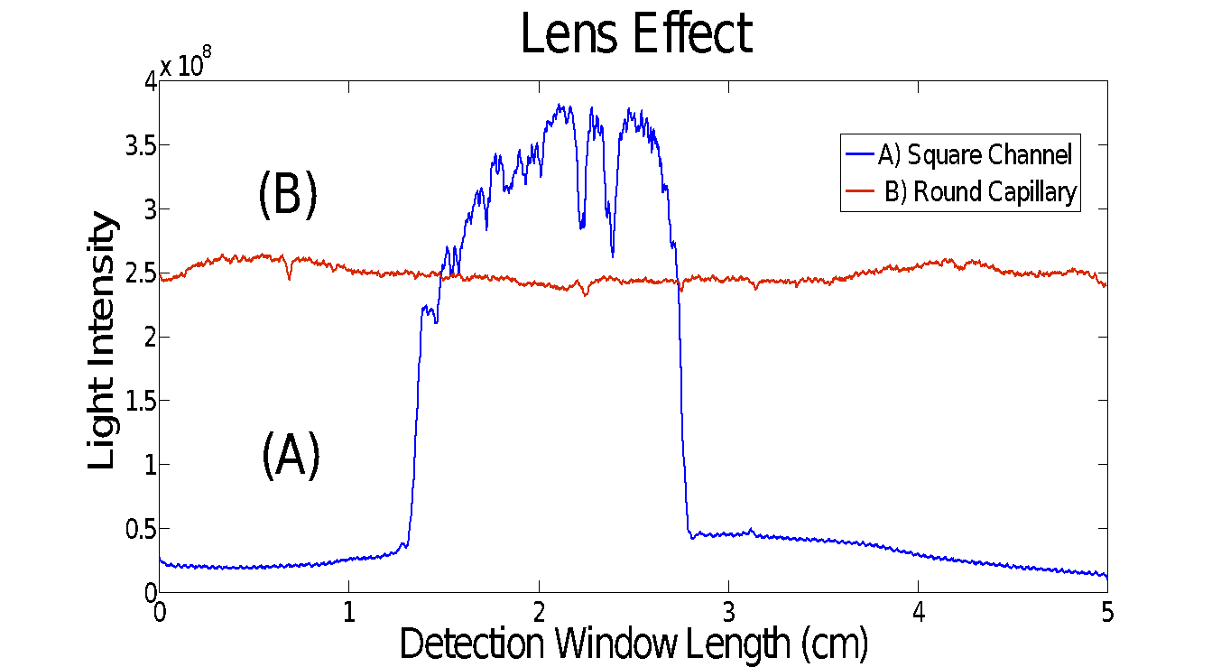
The curvature of the capillary acts as a thick cylindrical lens with a short focal length and bends the incoming beam. Hence, the lens effect causes the collimated incoming light beam to become strongly un-collimated, and as a result, the stray light makes the light collection inefficient. This drawback can be addressed by using microchips with a rectangular channel. The reduction of beam scattering and distortion by means of the flat channel walls is very important for path-length-dependent optical detection schemes. Tsuda et al. reported increase in the sensitivity of UV-vis absorbance detection method by running capillary zone electrophoresis inside rectangular silica capillary, although at the expense of peak broadening ⁵.
Figure S-5 Comparison of the light intensity after passing through a round and square separation column: (A) 100 μm x 100 μm x 1.8 cm; (B) 100 μm ID x 5 cm. The separation columns were filled with water. Exposure time equals to 250 μs.

The Capillary Cartridge vs. The Multi-channel Chip
The capillary isoelectric focusing experiments were performed by UV whole column imaging detection in channel C of the microchip as an identical separation column to the capillary. The results provide insight about the chip performance compared to the capillary cartridge. Here, some of the key features of the multi-channel chip are summarized and compared to the commercial capillary cartridge. A straightforward advantage of using microchip in CIEF-WCID is the absence of lens effect, which contributes to better detection sensitivity. The COC-chips are provided by their manufacturer as disposable products, however, according to the non-destructive nature of the employed chemicals, each chip can be used for 15 runs on average within three days, with narrower channels being subjected to blocking faster.
Table S-1 Side-by-side comparison of the disposable multi-channel chip with the commercial capillary cartridge.
Feature | Multichannel Chip | Capillary Cartridge
Material | Plastic (COC) | Fused silica
EOF | Negligible | Need suppression ª
Lens effect ^{b} | NA | Present
Durability | 15 runs ^{c} | 100 runs ⁶
Cost | $ 60 ^{d} | $ 250
RSD | < 2% | < 0.5%
Throughput | 8 channels | Single capillary
a) Especially at pH values greater than three. b) Created by the round shape of the separation column.
c) Within three consecutive days. d) The photo mask layer price is not included.

Table S-2 Employed channels' specifications. SVR: Surface Area to Volume Ratio
Channels’ specifications | C | D | E | Capillary
Width × depth (μm²) | 100 ×100 | 50 ×50 | 100 ×50 | ID=100
SVR (μM⁻¹) | 0.04 | 0.08 | 0.06 | 0.04
Hydraulic diameter, D_{H} (μm) | 100 | 50 | 67 | 100
Duct geometry | Square | Square | Rectangular | Circular

References
(1) Huang, C.; Gregory, J. W.; Sullivan, J. P. Meas. Sci. Technol. 2007, 18, N32.
(2) Mao, Q.; Pawliszyn, J. J. Biochem. Biophys. Methods 1999, 39, 93–110.
(3) Rilbe, H. Ann. New York Acad. Sci. NY Acad. Sci. 1973, 209, 11–22.
(4) Wu, J.; Tragas, C.; Watson, A.; Pawliszyn, J. Anal. Chim. Acta 1999, 383, 67–78.
(5) Tsuda, T.; Sweedler, J. V.; Zare, R. N. Anal. Chem. 1990, 62, 2149–2152.
(6) Liu, Z.; Ou, J.; Samy, R.; Glawdel, T.; Huang, T.; Ren, C. L.; Pawliszyn, J. Lab Chip 2008, 8, 1738–1741.
(7) J. PAWLISZYN, J. W. 1991, 559, 111–118.
(8) Lv, H.; Yan, W.; Yang, X.; Li, J.; Zhu, J. Meas. Sci. Rev. 2012, 12, 272–276.
(9) Dada, O. O.; Ramsay, L. M.; Dickerson, J. a; Cermak, N.; Jiang, R.; Zhu, C.; Dovichi, N. J. Anal. Bioanal. Chem. 2010, 397, 3305–3310.
(10) Wu, J.; Pawliszyn, J. Analyst 1995, 120, 1567–1571.
(11) Ali, I.; Aboul‐Enein, H. Y.; Gupta, V. K. Anal. Lett. 2006, 39, 2345–2357.
(12) Kamholz, a E.; Schilling, E. a; Yager, P. Biophys. J. 2001, 80, 1967–1972.
(13) Kamholz, A. E.; Weigl, B. H.; Finlayson, B. a.; Yager, P. Anal. Chem. 1999, 71, 5340–5347.
(14) Wu, J.; Pawliszyn, J. Anal. Chem. 1992, 64, 219–224.
(15) Ye, F.; Jensen, H.; Larsen, S. W.; Yaghmur, A.; Larsen, C.; Østergaard, J. J. Pharm. Biomed. Anal. 2012, 61, 176–183.
(16) Liu, Z.; Lemma, T.; Pawliszyn, J. J. Proteome Res. 2006, 5, 1246–1251.

